AINNA

MALAYSIA AI COMMERCIALISATION PROPOSAL

AINNA × MTDC
Strategic NeuralOps Development, Validation, Commercialisation & Regional Scaling Proposal

PREPARED BY: AINNA
PROPOSED STRATEGIC COUNTERPARTS: Malaysian Technology Development Corporation (MTDC) and research partner
PROPOSED INFRASTRUCTURE LAYER: TM or another mutually agreed Malaysian infrastructure provider
POTENTIAL EXTENDED ECOSYSTEM: MIGHT, TAFE JD, PCG Edge and selected industry / regional partners - subject to separate agreements
DOCUMENT: Full Strategic Proposal

PROPOSAL FOR DISCUSSION
September 2026

Contents
1. Executive Overview
2. Strategic Context
3. Problem Statement
4. Proposed Collaboration Model
5. NeuralOps Technology Architecture
6. Strategic Objectives
7. Programme Workstreams
8. Initial Industry Priorities
9. Research & Talent Framework
10. Industry Pilot Framework
11. Infrastructure & Deployment Architecture
12. AI Governance, Cybersecurity & Data Protection
13. Intellectual Property & Commercial Rights
14. Commercialisation Model
15. MTDC Role & Funding Pathways
16. Corporate Investment Track
17. 18-Month Implementation Roadmap
18. KPI & Evaluation Framework
19. First-Year Targets
20. Risk Management
21. Commercial Scale & Regionalisation
22. Economic & Institutional Impact
23. Governance Structure
24. Decision Request & Immediate Next Steps
Appendix A. Funding-pathway matrix
Appendix B. Corporate financial snapshot
Appendix C. Source notes

1. Executive Overview
AINNA proposes a Malaysian NeuralOps Development, Validation & Commercialisation Programme designed to connect research, applied AI engineering, production infrastructure, industry validation and technology commercialisation in one stage-gated pathway.
The programme is intentionally structured as a decision and execution framework rather than a broad statement of collaboration. Each project begins with a measurable industry problem, is mapped to a suitable research and commercialisation pathway, is validated against an explicit baseline, and progresses to productisation only when technical and commercial evidence supports continuation.
Core principle
Use the right intelligence for the right task. NeuralOps routes work across deterministic rules, specialised parsers, smaller/focused models, large models and Detached Systems instead of defaulting every workload to a large generative model.

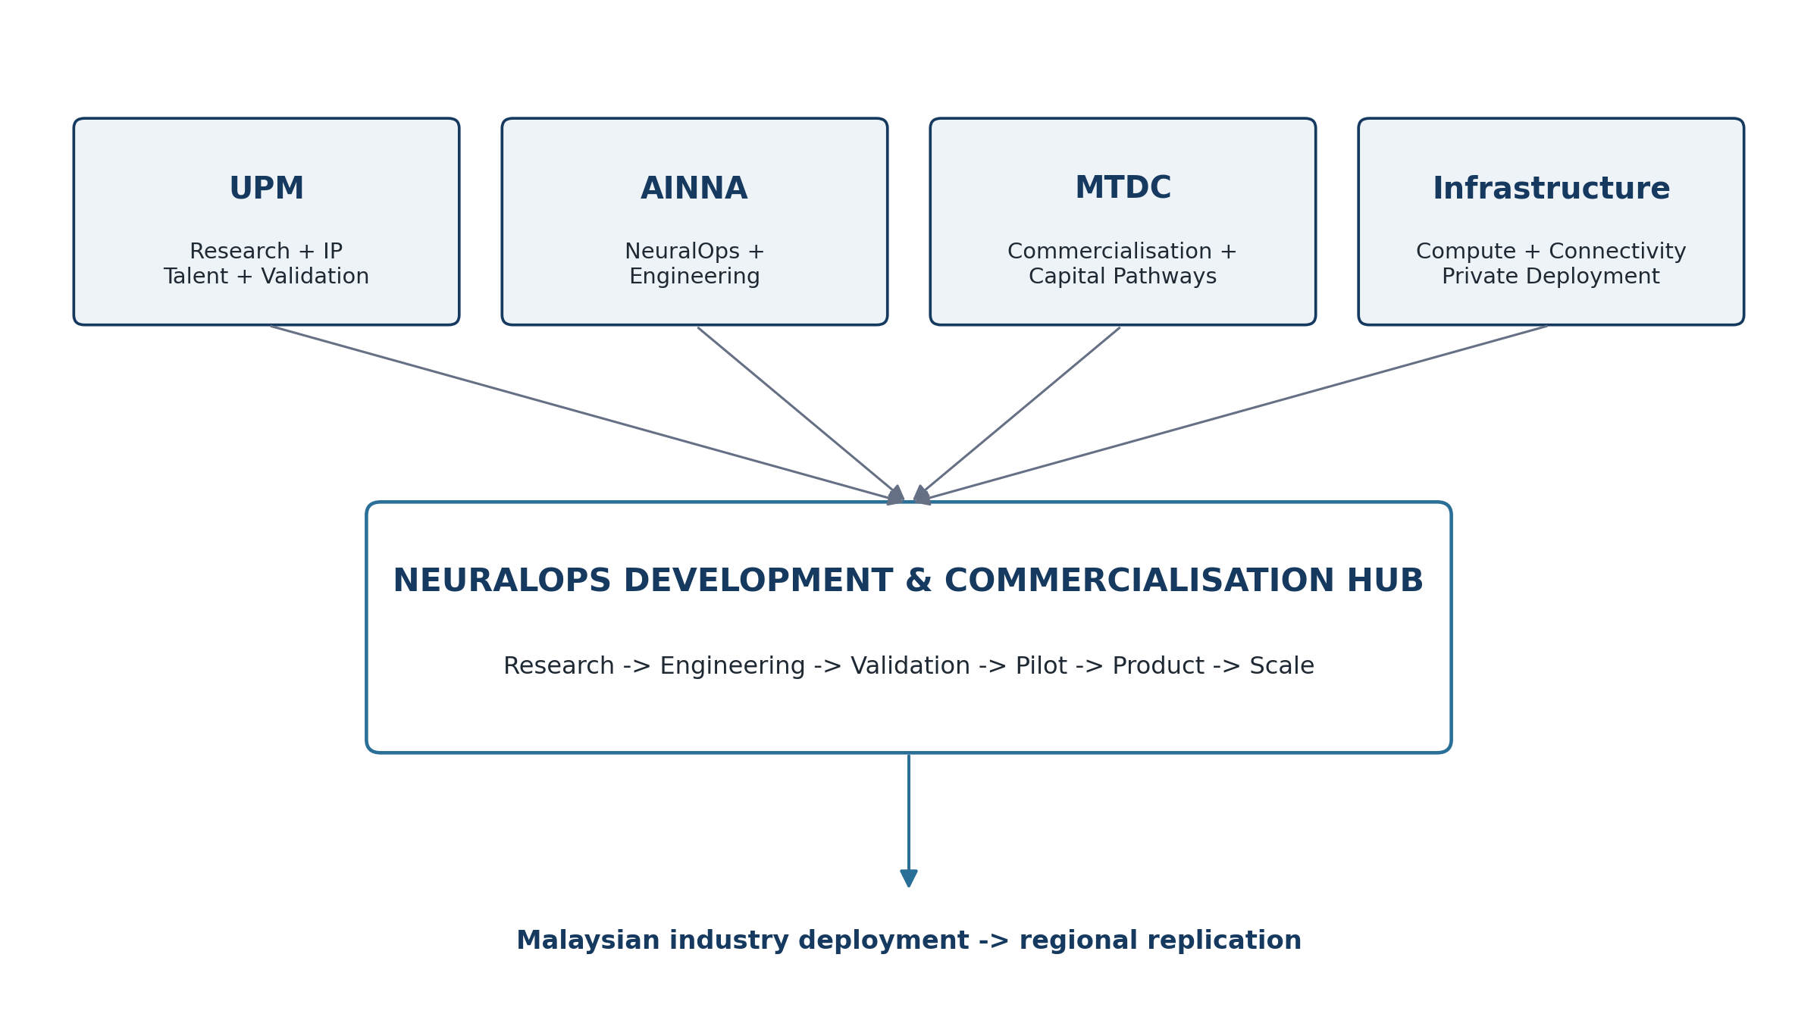
Figure 1. Proposed Malaysian research-to-commercialisation operating model.

2. Strategic Context
Enterprise AI is shifting from standalone chatbots and demonstrations toward systems embedded in operations. This changes the purchase criteria. Organisations increasingly need reliability, predictable economics, auditability, controlled data handling, private or hybrid deployment, model choice, integration with existing systems and clear human accountability.
For Malaysian SMEs and institutions, a model-centric architecture can be economically and operationally inefficient when repetitive or deterministic business processes are repeatedly sent through generative AI. The opportunity is to build an orchestration layer that reserves advanced generative reasoning for tasks that genuinely need it and executes structured workloads through more controllable mechanisms.
In parallel, Malaysia already has research institutions, commercialisation agencies, technology companies, infrastructure providers and industry customers. The strategic gap is orchestration between these actors: turning a research output or operational problem into validated technology, then into a repeatable commercial product.

3. Problem Statement

3.1 Model overuse and cost unpredictability
General-purpose models are often used for structured tasks that can be handled more reliably through rules, parsers or conventional software. This creates unnecessary inference, latency and operating-cost variability.

3.2 Reliability and hallucination exposure
Generative systems may produce plausible but incorrect outputs. High-value operational systems therefore require deterministic controls, validation, exception handling and human checkpoints.

3.3 Data-control and governance constraints
Organisations may be unable or unwilling to send sensitive operational data to external services. Local-first, private and hybrid deployment options are increasingly important.

3.4 Research-to-market fragmentation
University research can stall between IP creation, market validation, product engineering and customer acquisition. Commercialisation requires a dedicated bridge across those stages.

3.5 Proof-of-concept stagnation
Many pilots demonstrate technical capability but lack a defined paying customer, conversion threshold, service model or product owner. This proposal requires an explicit commercial end-state from the beginning.

3.6 SME outcome gap
SMEs buy outcomes - faster reconciliation, fewer stock errors, better customer follow-up, lower admin burden - not model parameters. The product must be designed around those outcomes.

4. Proposed Collaboration Model
The collaboration is proposed as a consortium-style programme with clearly separated roles. The labels below describe intended contributions only; they do not constitute a binding partnership, procurement, investment or government commitment.

Research - IP & Validation
- Academic and applied research
- Researchers and postgraduate talent
- Domain expertise and scientific methodology
- Technology and market validation where appropriate
- Potential eligible institutional IP commercialisation through existing institutional processes

AINNA - Engineering & Productisation
- NeuralOps architecture and orchestration
- AI agents and smart routing
- Specialised parsers and deterministic validation
- Detached processing systems
- Application, API and integration engineering
- Deployment, monitoring and product design

MTDC - Commercialisation & Capital Pathways
- Commercial readiness and business-model discipline
- Industry introductions and market access
- Technology investment / developmental-fund pathways subject to eligibility
- Value-creation support for technology companies
- Scaling and investment-readiness support

Infrastructure Provider - Production Layer
- Private/local AI infrastructure
- Compute, storage and connectivity
- VPN and secure environment
- Production deployment, monitoring and resilience
- Cloud, hybrid or on-premise patterns

Industry Partners - Validation & Customers
- Business problem ownership
- Operational data under agreed governance
- Baseline and target measurements
- User validation
- Commercial conversion and reference deployments

5. NeuralOps Technology Architecture
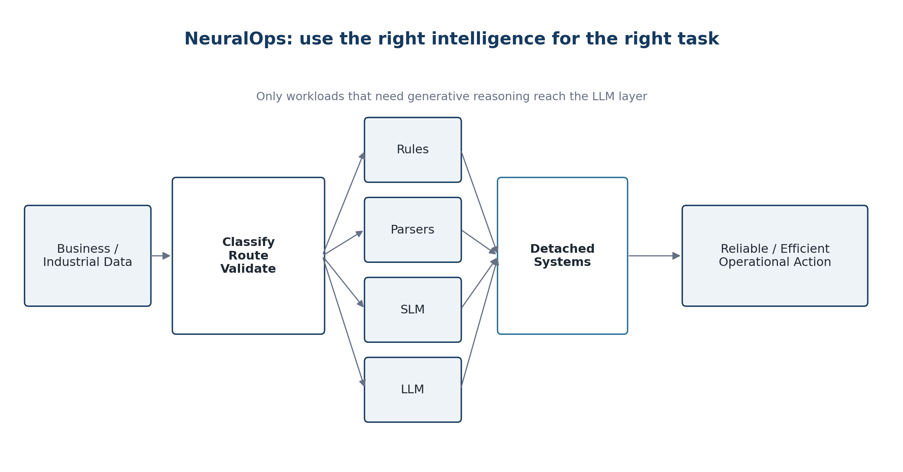
Figure 2. NeuralOps orchestration logic.
NeuralOps is positioned as an orchestration and execution architecture rather than another foundation model. It evaluates a workload, selects an appropriate processing path, validates the result and progressively converts stable repetitive workloads into lower-cost Detached Systems where appropriate.

Layer 1 - Deterministic Rules
Known logic, calculations, validation, permissions, routing conditions and repeatable business rules.

Layer 2 - Specialised Parsers
Structured extraction and transformation for documents, transactions, forms and known data formats.

Layer 3 - Small / Focused Models
Classification, extraction, vision or domain-specific intelligence where a smaller model is sufficient.

Layer 4 - Large Language Models
Complex natural-language reasoning, flexible interpretation and unstructured tasks that require generative capability.

Layer 5 - Detached Systems
Stable repeatable workflows are converted into conventional services, automation or deterministic logic so they no longer require repeated LLM inference.
Operator evidence and limitation
AINNA management materials currently report 259 scenario-library entries, 14 production systems, a seven-model on-premise LLM orchestra and an 87% internal token-reduction benchmark for a specific workload. These indicators should be independently validated in the proposed programme; they are not universal performance guarantees.

6. Strategic Objectives
1. Create a repeatable Malaysian pathway from research and industry problems to deployable AI products.
2. Validate whether NeuralOps materially improves reliability, efficiency, data control and cost predictability across selected workloads.
3. Develop reusable Malaysian IP, software modules, datasets and deployment patterns.
4. Create commercial products rather than isolated proof-of-concept projects.
5. Build a pipeline for postgraduate and researcher participation in real commercial AI engineering.
6. Establish responsible-AI, privacy, auditability and human-accountability controls as engineering requirements.
7. Create a production architecture that can support Malaysian SMEs, enterprises and institutional customers.
8. Prepare successful sector solutions for regional replication through separately contracted market partners.

7. Programme Workstreams

A. NeuralOps Core
Routing, orchestration, model management, rules, checkpoints, idempotency, observability and failure recovery.

B. Specialised AI
Domain modules for classification, extraction, anomaly detection, computer vision, decision support and domain-specific workflows.

C. Detached Systems
Identification and conversion of stable repetitive AI workloads into deterministic or semi-deterministic services.

D. Research & Validation
Benchmark design, datasets, controlled experiments, reproducible evaluation and independent technical reporting.

E. Production Infrastructure
Reference architectures for shared cloud, dedicated VPS, private GPU, hybrid and on-premise deployment.

F. Commercialisation
Customer discovery, pricing, product packaging, procurement readiness, service levels, sales channels and scale economics.

G. Governance & Security
AI risk classification, data protection, access control, logging, human oversight, incident management and cybersecurity review.

8. Initial Industry Priorities
The AINNA concept site lists multiple industries. For the first programme cycle, the recommended approach is to concentrate resources in four areas where measurable operational problems and Malaysian strategic relevance can be demonstrated.

8.1 SME Finance & Compliance
- Bank-statement reconstruction and transaction processing
- Reconciliation and exception detection
- Management-report preparation
- Audit / accounting preparation support
- Document validation and structured financial workflows

8.2 Manufacturing & Quality
- Quality documentation and inspection
- Machine / production data processing
- SOP intelligence and operator support
- Maintenance and anomaly detection
- Industry 4.0 integration

8.3 Agriculture & Food Security
- Sensor and farm-record processing
- Computer vision for crop / livestock monitoring
- Traceability and anomaly detection
- Resource and yield optimisation
- Operational dashboards and alerts

8.4 Retail, Logistics & Supply Chain
- Inventory and demand intelligence
- Warehouse and fulfilment workflows
- Procurement support
- Marketplace reconciliation
- Shipment and exception monitoring

9. Research & Talent Framework
research partner participation should be designed as genuine research and validation collaboration rather than simple talent outsourcing. Putra Science Park and InnoHub already operate structured processes for market validation, commercialisation and startup creation from eligible institutional IP, providing a relevant institutional interface for selected projects.
- Research question formulation and experimental design.
- Dataset design, annotation strategy and evaluation methodology.
- Independent benchmark and validation work.
- Domain expertise in selected verticals.
- Postgraduate research aligned with technically meaningful project questions.
- Potential eligible institutional IP licensing or startup pathways when the selected project uses eligible eligible institutional IP.
- Research outputs, technical reports and publications where compatible with commercial confidentiality and IP strategy.
Important eligibility distinction
Institutional InnoHub market-validation funding is designed around intellectual property and institutional programme participation. It should not be represented as a general corporate grant available to AINNA. A project must be structured around eligible eligible institutional IP / researchers and institutional requirements.

10. Industry Pilot Framework
Every pilot must start with a measurable business problem and a named operational owner. The programme should reject pilots that cannot define a baseline, target and decision rule for continuation.
Example pilot statement
Instead of “deploy AI for a manufacturer,” define “reduce QA document-processing time from the current baseline by at least 40% while maintaining an independently validated output-accuracy threshold and keeping exception handling within the agreed human-review process.”

10.1 Minimum pilot specification
- Problem statement and operational owner
- Current process and baseline metrics
- Target performance and minimum acceptable threshold
- Data source and data-governance classification
- Proposed NeuralOps routing architecture
- Human review and escalation requirements
- Infrastructure and security environment
- Test plan and evaluation method
- Commercial buyer and procurement pathway
- Conversion criteria, pricing hypothesis and post-pilot owner

10.2 Stage-gate decisions
1. Gate 1 - Problem fit: proceed only if there is a measurable problem and owner.
2. Gate 2 - Technical feasibility: proceed only if required data and architecture are viable.
3. Gate 3 - Controlled validation: proceed only if technical thresholds are met.
4. Gate 4 - Commercial fit: proceed only if buyer, value and pricing are credible.
5. Gate 5 - Productisation: standardise only if reuse across customers is plausible.
6. Gate 6 - Scale: allocate major capital only after evidence of repeatability and customer conversion.

11. Infrastructure & Deployment Architecture
The production layer should support multiple deployment modes so the system can match cost, privacy, latency and operational requirements. The preferred provider can be TM if commercial and technical terms are suitable, but the reference architecture should remain sufficiently provider-agnostic to avoid unnecessary dependency.

Shared secure cloud
Lower-risk and SME workloads requiring fast deployment and efficient shared infrastructure.

Dedicated VPS
Customer isolation and predictable application resources.

Private GPU environment
Higher-volume or sensitive inference where local/private model execution is required.

On-premise
Institutional or enterprise workloads requiring maximum local control.

Hybrid
Sensitive/repetitive tasks execute locally while controlled external model calls are used selectively.

11.1 Minimum platform controls
- Encryption in transit and at rest
- Role-based access control
- VPN / private connectivity where appropriate
- Environment isolation
- Audit logging
- Backup and recovery
- Model, prompt and rules versioning
- Observability and alerting
- Rollback and checkpoint capability
- Capacity and cost monitoring

12. AI Governance, Cybersecurity & Data Protection
Responsible AI should be embedded in architecture, not added as a post-deployment policy. Malaysia's National Guidelines on AI Governance and Ethics (AIGE) provide a voluntary national reference for responsible AI development and use. The programme should map relevant controls to the risk profile of each use case.

12.1 AI governance controls
- AI risk classification before deployment
- Human approval for material decisions
- Transparent exception and escalation logic
- Documented model / rule / prompt versions
- Evaluation records and known limitations
- Bias / performance testing where relevant
- Output provenance and traceability where practical
- Incident response and rollback

12.2 Personal data protection
Malaysia's Personal Data Protection (Amendment) Act 2024 came into operation in stages during 2025. Where personal data is processed, each project should explicitly identify data-controller / processor roles, purposes, retention, access, security, cross-border considerations and incident responsibility. Higher-risk deployments should consider a Data Protection Impact Assessment and privacy-by-design review.

12.3 Cybersecurity
- Secure software-development lifecycle
- Secrets and API-key management
- Dependency and patch management
- Network segmentation
- Least-privilege access
- Penetration / vulnerability testing proportional to risk
- Logging and security monitoring
- Recovery objectives and disaster-recovery testing

13. Intellectual Property & Commercial Rights
IP terms must be established before substantive joint development. Ambiguous ownership is one of the fastest ways to block commercialisation after a technically successful project.
IP category | Recommended treatment
Background IP | Technology, software, data, models or know-how owned before the project. Existing AINNA NeuralOps components remain AINNA background IP unless separately agreed; existing eligible institutional IP remains governed by ownership arrangements.
Project IP | New technology created specifically through the collaboration. Ownership should reflect inventorship, funding, contribution and contractual terms.
Data rights | Operational data remains subject to customer / controller rights and agreed use limitations. Training or derivative use must be separately authorised.
Commercialisation rights | Licensing, exclusivity, territories, field-of-use, royalties, support, derivative works and improvement rights should be expressly documented.
Publication rights | Research publication should be balanced with patent filing, trade-secret protection and customer confidentiality through review windows and agreed procedures.

14. Commercialisation Model
The programme should support multiple revenue mechanisms because different technologies and customers require different procurement models. The preferred outcome is recurring and repeatable revenue rather than a portfolio dominated by one-off custom projects.

NeuralOps Platform subscription
Recurring orchestration, model management and workflow capability.

NeuralOps API
Integration into customer applications and existing systems.

Vertical SaaS
Industry-specific products such as finance, compliance, manufacturing or logistics modules.

Enterprise private deployment
Dedicated or on-premise systems with implementation and support.

Integration & automation services
Paid implementation, workflow integration and system customisation.

Managed AI infrastructure
Recurring management of private / hybrid environments.

Technology / IP licensing
Licensing of eligible modules, patents, models or research-derived technology.

Regional implementation
Localisation and deployment through separately contracted regional partners.

14.1 Commercialisation rule
Commercial discipline
A pilot is not considered successful merely because the technology works. Success requires a credible path to a paying customer, repeatable deployment, supportability and economics that justify scale.

15. MTDC Role & Funding Pathways
MTDC's official technology-investment positioning spans de-risking / seed through growth and identifies Industry 4.0 / 4IR and Food Security among six core sectors. The proposed programme aligns with MTDC's commercialisation and technology-company development mandate, but any funding or investment must be matched to the correct scheme and formal eligibility.

15.1 Recommended pathway logic
1. If a project is based on eligible research/IP and is still in technology / market validation, evaluate University Sandbox and Institutional InnoHub routes.
2. If AINNA as a Malaysian private limited company needs technology / market validation, evaluate the NTIS Validation Sandbox subject to NTIS acceptance and matching terms.
3. If the technology has completed validation and requires commercialisation capital, evaluate the Commercialisation Sandbox.
4. If an established corporate partner will co-invest in validation/commercialisation, evaluate the Corporate Sandbox.
5. If a validated Malaysian technology is entering a foreign market, evaluate the Global Sandbox and other international-commercialisation mechanisms.

15.2 Funding-pathway matrix
Scheme | Published mechanism | Duration | Best-fit use | Critical condition
University Sandbox | Full grant up to RM500k | 12 months | University/RI technology + market validation | Researcher applicant; commercial partner ready; IP filed; NTIS acceptance.
Validation Sandbox | 70% matching convertible grant up to RM500k | 12 months | Company technology + market validation | Sdn Bhd; NTIS acceptance; matching terms.
Commercialisation Sandbox | 70% matching hybrid funding up to RM4m | 18 months | Commercialisation after validation | Grant + Convertible Promissory Note; commercialisation activities.
Corporate Sandbox | 1:1 matching grant up to RM2m | 18 months | Corporate co-invested validation / commercialisation | Established corporate partner co-invests.
Global Sandbox | 70% matching convertible grant up to RM2m | 12 months | Foreign validation / expansion / localisation | Localisation / IP conditions and NTIS requirements.
Institutional InnoHub | Up to RM100k (2026 cohort) | Programme-specific | Guided market validation for eligible institutional IP | eligible institutional IP and institutional programme eligibility.
Funding caveat
All scheme details above are based on official public pages accessed 7 September 2026 and remain subject to current programme availability, NTIS acceptance where applicable, fund-committee approval, matching requirements, conversion terms, caps, institutional rules and due diligence.

16. Corporate Investment Track
Research collaboration, project funding and equity investment should remain separate decisions. This avoids making technical collaboration contingent on a corporate financing round and allows each decision to be evaluated under the correct governance and due-diligence process.
AINNA's current management investor materials state a seed raise of RM2.0 million for 10% equity, corresponding to RM18.0 million pre-money and RM20.0 million post-money. This is AINNA's management proposition and is not a valuation endorsed by MTDC or any third party.
Allocation | Share | Amount
AI infrastructure & capability | 50% | RM1,000,000
Inventory & market expansion | 30% | RM600,000
OPEX | 20% | RM400,000
Total | 100% | RM2,000,000
Recommended governance: any equity-investment discussion should include financial, legal, IP, technical, cybersecurity, market and management due diligence independently of the proposed research programme.

17. 18-Month Implementation Roadmap
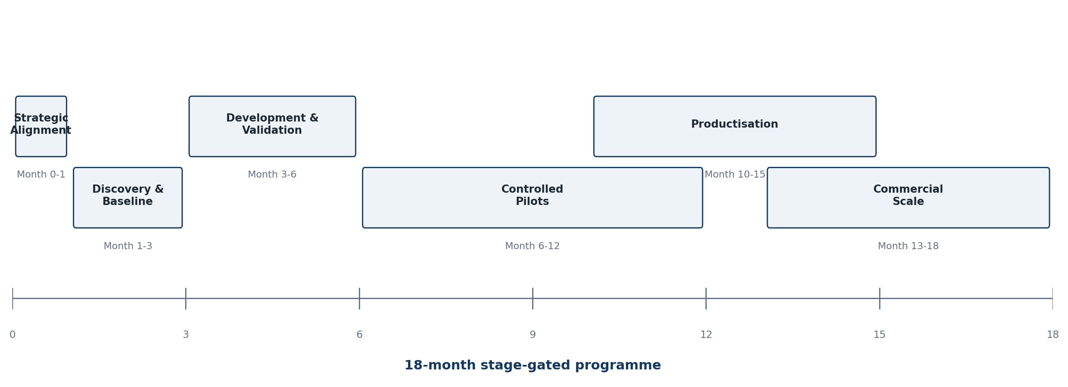
Figure 3. Recommended 18-month stage-gated roadmap.

Phase 0 - Strategic Alignment | Month 0-1
- Steering group and governance
- Priority vertical selection
- IP / data principles
- Initial industry and research participants
- Funding-pathway mapping

Phase 1 - Discovery & Baseline | Month 1-3
- Process mapping
- Data inventory
- Current-state benchmark
- Risk classification
- Commercial buyer and value hypothesis

Phase 2 - Development & Validation | Month 3-6
- NeuralOps configuration
- Parser / rule / agent development
- Model selection
- Evaluation platform
- Controlled prototype tests

Phase 3 - Controlled Pilots | Month 6-12
- Production-like deployment
- Technical and operational measurement
- User validation
- Security / governance tests
- Pilot-to-commercial decision

Phase 4 - Productisation | Month 10-15
- Standardised architecture
- Documentation and onboarding
- Pricing and SLA
- Support model
- Procurement and compliance readiness

Phase 5 - Commercial Scale | Month 13-18
- Paid conversion
- Repeatable customer acquisition
- Channel partners
- Regional readiness
- Follow-on investment decision

18. KPI & Evaluation Framework
Dimension | Measurement | Decision Use
Accuracy / quality | Task-specific validated accuracy, precision/recall or acceptance rate | Production-readiness gate.
Hallucination / exception | Unsupported output rate, validation failure, exception frequency | Risk and human-review design.
Model consumption | Token / inference calls, local-vs-external routing | Tests smart-routing hypothesis.
Compute & power | GPU/CPU utilisation, processing load, energy where measurable | Capacity and ESG optimisation.
Speed | Latency and end-to-end process time | Operational benefit.
Cost | Cost per task / customer / workflow | Commercial viability.
Human intervention | Review frequency, escalation rate, manual minutes | Automation effectiveness and control.
Reliability | Availability, retry success, checkpoint / recovery performance | Production operations.
Commercial | Paid conversion, ARR/MRR, retention, deployment time | Product-market fit.
Research | Benchmarks, IP, datasets, reports, publications | Research contribution and defensibility.

18.1 Evaluation rule
Every percentage improvement must state the baseline, test set, time period, workload and methodology. Internal AINNA benchmarks should be clearly labelled internal until independently replicated or validated.

19. First-Year Targets
The following are proposed programme targets for negotiation. They are not current achievements or guaranteed outcomes.
Target | Recommended Year-1 range
Priority verticals | 2-4
Controlled industry pilots | 4-8
Independent NeuralOps benchmark studies | At least 2
Reusable commercial modules | 3-5
Pilot-to-paid conversions | At least 2
Common AI governance / evaluation framework | 1
Production reference architecture | 1
Formal commercialisation framework | 1

20. Risk Management
Risk | Failure mode | Mitigation
Technology risk | Outputs may be inaccurate or inconsistent. | Routing, deterministic validation, test sets, human checkpoints, rollback.
Commercial risk | Pilots may not convert to paying customers. | Customer discovery, named buyer, pricing hypothesis and conversion gate before development.
Scope risk | Too many sectors dilute engineering and research resources. | Limit first cohort and stage-gate expansion.
Research risk | Technically interesting work may lack market relevance. | Commercial assessment and industry sponsor from the beginning.
Data / privacy risk | Sensitive data may be mishandled. | Data minimisation, access control, privacy-by-design and DPIA where appropriate.
Cybersecurity risk | Agentic / connected systems expand attack surface. | Least privilege, secret management, segmentation, monitoring and security testing.
IP risk | Ownership ambiguity blocks commercialisation. | Background/project IP schedule and commercial terms before substantive work.
Infrastructure risk | Compute assumptions may be wrong. | Benchmark workloads, capacity planning, routing and provider flexibility.
Partner risk | Responsibilities or expectations become unclear. | Programme charter, RACI, steering governance and work orders.
Reputation risk | Overstated AI claims damage credibility. | Evidence labelling, independent validation and claim-review process.

21. Commercial Scale & Regionalisation
Regional expansion should follow evidence, not precede it. The recommended path is to standardise validated Malaysian solutions before localisation for foreign markets.
1. Pilot in Malaysia.
2. Validate technical and commercial outcomes.
3. Convert the solution into a reusable NeuralOps module / product.
4. Deploy to multiple Malaysian customers.
5. Establish documented implementation, support and governance standards.
6. Localise for selected regional markets through separately contracted partners.
7. Use foreign expansion funding / investment only when the product has credible repeatability.
AINNA's current strategic concept identifies MIGHT, TAFE JD and PCG Edge as potential elements of a wider Malaysia-to-GCC execution pathway. Those roles should remain explicitly proposed until formal agreements, mandates or transactions exist.

22. Economic & Institutional Impact

SMEs
Lower repetitive administrative workload, better information flow, faster operational decisions, improved automation and access to controlled AI.

Technology industry
Local AI engineering jobs, reusable software IP, private-infrastructure capability and more Malaysian technology companies.

research ecosystem
Industry-linked research questions, commercialisation pathways, postgraduate exposure, datasets and potential licensing.

MTDC / commercialisation ecosystem
A pipeline of validated technology opportunities with explicit market and scale gates.

National capability
Stronger domestic AI deployment capability, improved data locality, SME digitalisation and potential exportable technology.

Regional opportunity
Malaysia becomes the development and IP base for selected solutions that are later localised for ASEAN / GCC markets.

23. Governance Structure

23.1 Steering Committee
- AINNA representative(s)
- / Putra Science Park or relevant faculty / research representatives
- MTDC representative(s)
- Infrastructure provider representative where relevant
- Lead industry-pilot representative where appropriate

23.2 Working groups
- Technology & architecture
- Research & validation
- Commercialisation & market
- Governance, data protection & cybersecurity
- Industry deployment & operations

23.3 Governance documents
- Programme Charter
- RACI / role matrix
- IP and confidentiality framework
- Data-sharing / processing agreements where applicable
- Pilot work orders
- Evaluation protocol
- Stage-gate decision record
- Commercialisation / licensing agreement for successful projects

24. Decision Request & Immediate Next Steps
Requested decision
Approve an initial strategic alignment process - not a full-scale rollout - to select the first 2-4 problems, establish project governance and determine the correct research and funding pathways.

Step 1 - Strategic Alignment Meeting
AINNA presents NeuralOps architecture, operator validation, candidate problems and current commercial model.

Step 2 - Technical & Research Workshop
and AINNA select the technically meaningful research / validation questions and identify suitable researchers.

Step 3 - Commercialisation Workshop
MTDC evaluates market relevance, funding / investment pathways, commercial readiness and potential pilot companies.

Step 4 - Pilot Selection
Rank candidate pilots by measurable value, data availability, technical feasibility, commercial buyer and reusability.

Step 5 - Programme Charter
Confirm roles, IP, data governance, funding, milestones, KPIs, reporting and stage-gate authority.

Step 6 - Controlled Development
Build and validate only the selected first-cohort projects.

Step 7 - Commercial Decision
Scale, licence, subscribe, spin out, partner or terminate based on evidence.
Strategic proposition
Research in Malaysia. Engineered in Malaysia. Validated with industry. Commercialised in Malaysia. Scaled to the region.

Appendix A. Funding-pathway matrix
The following matrix is a structuring aid only. Formal eligibility must be confirmed with MTDC / NTIS based on the specific applicant, IP, project scope, matching requirements and programme status at the time of application.
Pathway | Published mechanism | Best-fit proposal use | Key eligibility / caution
MTDC University Sandbox | Up to RM500k full grant; 12 months | research-partner-led technology and market validation with AINNA as commercial partner | University/RI researcher; commercial partner ready; IP filed; NTIS acceptance.
MTDC Validation Sandbox | Up to RM500k; 70% matching convertible grant; 12 months | AINNA-led company technology and market validation | Malaysian Sdn Bhd; NTIS acceptance; matching and conversion terms.
MTDC Commercialisation Sandbox | Up to RM4m; 70% matching hybrid funding; 18 months | Post-validation commercialisation and scale | Commercialisation activities; grant plus CPN structure; eligibility and approval.
MTDC Corporate Sandbox | Up to RM2m; 1:1 matching grant; 18 months | Enterprise or infrastructure co-investment model | Established corporate partner must co-invest with MTDC.
MTDC Global Sandbox | Up to RM2m; 70% matching convertible grant; 12 months | Foreign validation, localisation and regional expansion | Localisation/IP conditions and NTIS requirements apply.
Institutional InnoHub | Up to RM100k for the 2026 cohort; programme-specific | Guided market validation where eligible institutional IP is central | eligible institutional IP and institutional programme eligibility; not a general AINNA corporate grant.

Appendix B. AINNA corporate financial snapshot
This appendix is included because MTDC may evaluate both commercialisation support and corporate investment. It is not a funding request to and should not be interpreted as an agreed consortium budget.
Management metric | Current AINNA target / proposition
Seed raise | RM2.0m
Equity offered | 10%
Pre-money valuation | RM18.0m
Post-money valuation | RM20.0m
Year-1 revenue target | RM2.852m
Year-1 recurring ARR target | RM1.784m
5-year combined revenue target | RM88.412m
Year-1 NeuralOps customer target | 500
All revenue and customer figures are management targets, not guaranteed forecasts. The current AINNA five-year model assumes aggressive customer growth and should be independently stress-tested during investment due diligence.

References and source notes
Accessed 7 September 2026. Funding schemes, programme conditions and website information may change; formal eligibility and approval must be confirmed directly with the relevant organisation before submission or commitment.
[1] AINNA - MTDC - Strategic AI Commercialisation proposal. Primary AINNA concept source for proposed consortium roles, NeuralOps positioning, industries and roadmap. https://ainna.bond/ainna-mtdc-upm-website/
[2] AINNA NeuralOps Investor Overview. AINNA management source for internal validation indicators, investment terms and financial targets. https://ainna.bond/pitch1/
[3] MTDC National Technology & Innovation Sandbox Fund. Official published NTIS scheme types, amounts, mechanisms, eligibility and funding scopes. https://www.mtdc.com.my/national-technology-innovation-sandbox-fund/
[4] MTDC Technology Investment. Official MTDC technology-investment mandate and sector focus. https://www.mtdc.com.my/tech-investment/
[5] Putra Science Park - InnoHub New Application. Official information on 2026 InnoHub market-validation grant and purpose. https://sciencepark.upm.edu.my/innohub/innohub_program/new_application-59160
[6] Putra Science Park - InnoHub Startup Company. Official description of eligible institutional IP-to-startup commercialisation pathway. https://sciencepark.upm.edu.my/innovation_journey/stage_3_innohub_startup_company-16178?L=en
[7] Malaysia National Guidelines on AI Governance and Ethics (AIGE). National responsible-AI governance reference. https://www.malaysia.gov.my/en/my-initiative/whole-government-digital-services/tadbir-urus/national-guidelines-on-artificial-intelligence-governance-and-ethics-aige
[8] Personal Data Protection (Amendment) Act 2024 - commencement notice. Official commencement information for Malaysia PDPA amendments. https://www.pdp.gov.my/ppdpv1/en/personal-data-protection-amendment-act-2024-commencement-date-determination/
Prepared for strategic discussion. This proposal does not constitute an offer, grant approval, investment commitment, procurement award, legal partnership or representation on behalf of MTDC, , TM, MIGHT, TAFE JD, PCG Edge or any other third party.

