AINNA

MALAYSIA AI COMMERCIALISATION PROPOSAL

AINNA × MTDC
Strategic NeuralOps Development, Validation & Commercialisation Initiative

PREPARED BY: AINNA
PROPOSED STRATEGIC COUNTERPARTS: Malaysian Technology Development Corporation (MTDC) and research partner
PROPOSED INFRASTRUCTURE LAYER: TM or another mutually agreed Malaysian infrastructure provider
DOCUMENT: Executive Summary

PROPOSAL FOR DISCUSSION
September 2026

Executive decision summary
AINNA proposes a structured Malaysian pathway that connects university research, applied AI engineering, production infrastructure, industry validation and technology commercialisation. The proposed vehicle is a NeuralOps Development, Validation & Commercialisation Programme anchored in Malaysia and designed for repeatable deployment across selected industries.
Recommended decision
Form a joint working group and select 2-4 measurable industry problems for a 12-18 month stage-gated programme. Do not begin with a broad multi-sector rollout; begin with tightly scoped pilots that have defined baselines, commercial owners and conversion criteria.

The strategic problem
AI adoption is moving from experimentation to operations. The constraint is increasingly not access to a powerful model, but the ability to deploy AI with predictable cost, reliable outputs, auditable governance, data control and integration into real workflows.
At the same time, research institutions can possess valuable IP and domain expertise without a sufficiently direct route to product engineering, industrial validation and repeatable commercial deployment. The proposed collaboration is designed to close that research-to-market gap.

Proposed operating model
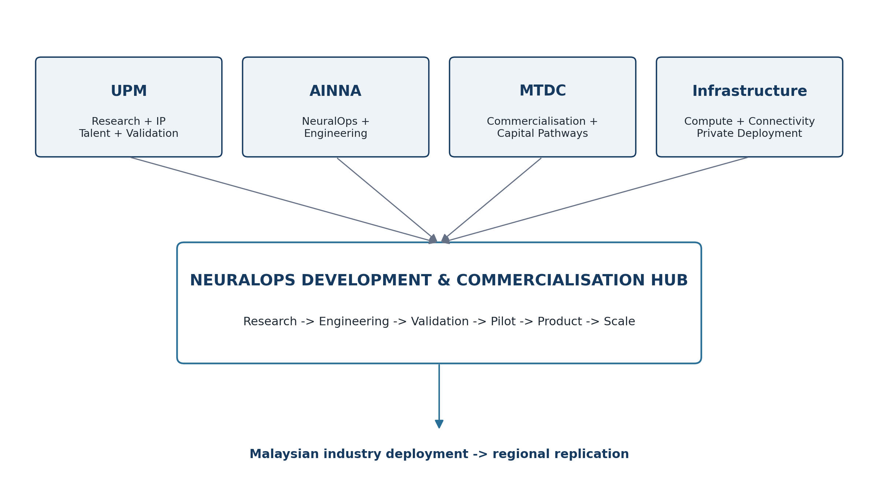
Figure 1. Proposed collaboration architecture. All roles are proposed and subject to agreement.
Party / Layer | Proposed contribution
 | Research, IP, postgraduate talent, independent validation and domain expertise.
AINNA | NeuralOps architecture, AI agents, smart routing, specialised parsers, Detached Systems, integration and product engineering.
MTDC | Commercialisation discipline, technology investment pathways, industry access, value creation and scaling support.
Infrastructure provider | Production compute, connectivity, private deployment, data locality and resilient operations.
Industry partners | Real operational problems, datasets, baseline measures, user validation and paying-customer conversion.

Why NeuralOps
NeuralOps treats large language models as one component inside an orchestration architecture rather than as the default processor for every workload. The system classifies work and directs it to deterministic rules, specialised parsers, smaller/focused models, large models or Detached Systems according to need.
- Reduce unnecessary generative-model calls for structured or repetitive workloads.
- Improve control through deterministic validation, checkpoints and human approval where material decisions are involved.
- Support local/private or hybrid deployment rather than forcing all data through external AI APIs.
- Create reusable systems that can be productised and deployed across customers.
Evidence position
AINNA currently reports 259 scenario-library entries, 14 production systems and an 87% internal token-reduction benchmark for a specific workload. These are operator/internal validation indicators, not independent third-party certifications or universal performance claims.

Recommended initial commercialisation lanes
1. SME Finance & Compliance - Document processing, bank-statement reconstruction, reconciliation, reporting, audit preparation and controlled finance automation.
2. Manufacturing & Quality - Production data, QA documentation, inspection, SOP intelligence, maintenance and Industry 4.0 workflows.
3. Agriculture & Food Security - Sensor and image intelligence, farm records, traceability, anomaly detection and resource optimisation.
4. Retail, Logistics & Supply Chain - Inventory, fulfilment, procurement, marketplace reconciliation, warehouse and shipment intelligence.

Funding pathways to evaluate - not approved funding
Pathway | Published mechanism | Potential fit | Key condition / caution
MTDC NTIS University Sandbox | Full grant up to RM500k; 12 months | research-partner-led technology and market validation | University/RI researcher; commercial partner ready; IP filed; NTIS acceptance required.
MTDC NTIS Validation Sandbox | 70% matching convertible grant up to RM500k; 12 months | AINNA-led company validation | Private limited company and NTIS acceptance; matching structure applies.
MTDC NTIS Commercialisation Sandbox | 70% matching hybrid funding up to RM4m; 18 months | Later-stage commercialisation | Commercialisation activities only; grant + CPN structure.
MTDC NTIS Corporate Sandbox | 1:1 matching grant up to RM2m; 18 months | Co-invested enterprise/corporate pilot | Established corporate partner must co-invest with MTDC.
MTDC NTIS Global Sandbox | 70% matching convertible grant up to RM2m; 12 months | Foreign validation / expansion | Localisation/IP conditions apply.
Institutional InnoHub Market Validation Grant | Up to RM100k for March 2026 cohort | Market validation of eligible institutional IP | Applies to eligible institutional IP and programme eligibility; not a general AINNA corporate grant.

18-month programme logic
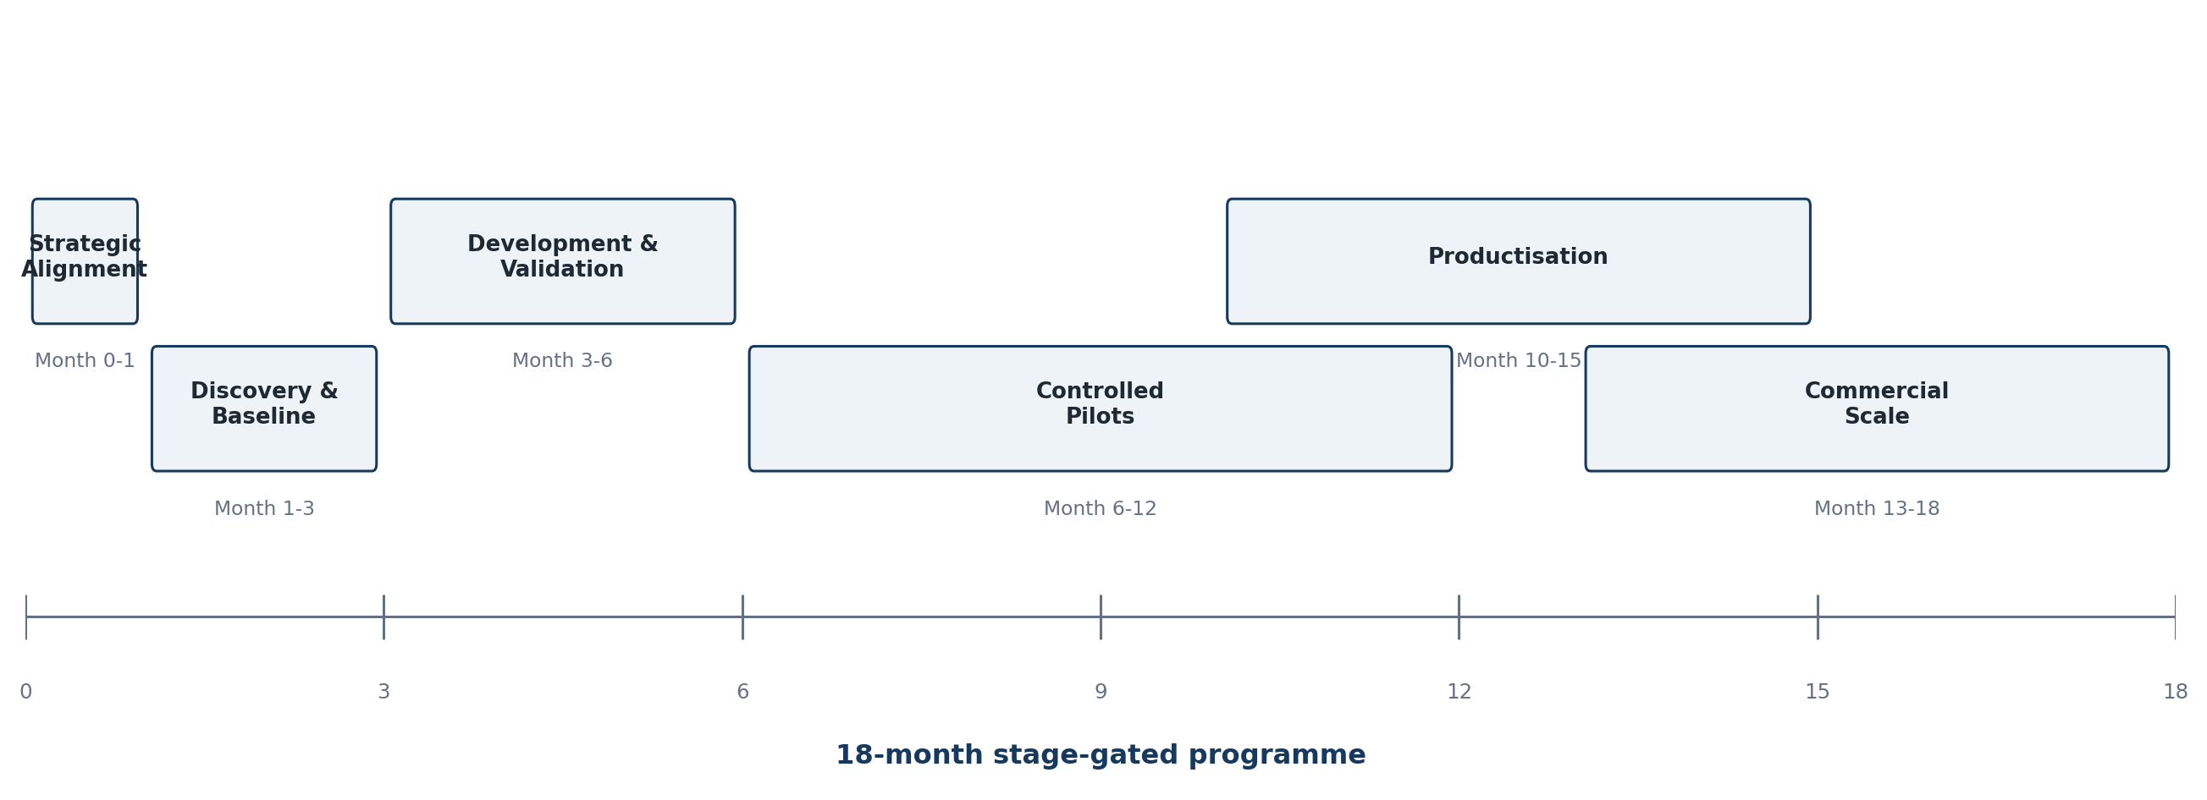
Figure 2. Recommended stage-gated programme roadmap.

Success measures
Dimension | Measurement | Decision Use
Technical | Accuracy, exception/hallucination rate, latency, availability | Determines whether a pilot is safe and production-worthy.
Efficiency | Token/model use, compute utilisation, energy where measurable, cost per task | Tests the NeuralOps efficiency thesis.
Operational | Human intervention, processing time, integration reliability | Tests whether the system improves actual work.
Commercial | Pilot-to-paid conversion, recurring revenue, deployment time, retention | Tests commercial product-market fit.
Research | Validated benchmarks, IP, datasets, publications / technical reports | Tests knowledge creation and research contribution.

Governance and legal position
The programme should be designed around human accountability, traceability, access control, evaluation records, data minimisation, incident handling and clear responsibility between technology provider, data controller and system user. Malaysia's National Guidelines on AI Governance and Ethics (AIGE) provide a voluntary national reference for responsible AI. Malaysia's Personal Data Protection (Amendment) Act 2024 commenced in stages during 2025, reinforcing the need for current privacy, data-controller and operational controls.
- Define background IP, project IP and commercialisation rights before substantive joint development.
- Use human approval checkpoints for material decisions and higher-risk workflows.
- Document datasets, model/rule versions, validation results, rollback and incident responsibility.
- Use DPIA / privacy-by-design processes where personal or sensitive operational data creates elevated risk.

Commercial model
- NeuralOps Platform subscriptions and API access.
- Industry-specific vertical SaaS products.
- Enterprise private deployments and managed infrastructure.
- Integration, automation and implementation services.
- Technology/IP licensing and joint commercialisation where ownership permits.
- Regional implementation programmes through separately contracted partners.
AINNA's corporate investment proposition should remain a separate workstream from research collaboration. Current management materials state a RM2.0m seed raise for 10% equity (RM18m pre-money / RM20m post-money), with investment and programme funding subject to independent due diligence and approval.

Decision requested
1. Agree in principle to form an AINNA-MTDC working group.
2. Select 2-4 priority industry problems with measurable baselines and named commercial owners.
3. Map each selected project to the correct research, funding and commercialisation pathway.
4. Agree IP, data governance, technical architecture, responsibilities and stage-gate KPIs before development.
5. Launch a controlled first cohort and make scale decisions only after measured evidence.
Strategic proposition
Research in Malaysia. Engineered in Malaysia. Validated with industry. Commercialised in Malaysia. Scaled to the region.

References and source notes
Accessed 7 September 2026. Funding schemes, programme conditions and website information may change; formal eligibility and approval must be confirmed directly with the relevant organisation before submission or commitment.
[1] AINNA - MTDC - Strategic AI Commercialisation proposal. Primary AINNA concept source for proposed consortium roles, NeuralOps positioning, industries and roadmap. https://ainna.bond/ainna-mtdc-upm-website/
[2] AINNA NeuralOps Investor Overview. AINNA management source for internal validation indicators, investment terms and financial targets. https://ainna.bond/pitch1/
[3] MTDC National Technology & Innovation Sandbox Fund. Official published NTIS scheme types, amounts, mechanisms, eligibility and funding scopes. https://www.mtdc.com.my/national-technology-innovation-sandbox-fund/
[4] MTDC Technology Investment. Official MTDC technology-investment mandate and sector focus. https://www.mtdc.com.my/tech-investment/
[5] Putra Science Park - InnoHub New Application. Official information on 2026 InnoHub market-validation grant and purpose. https://sciencepark.upm.edu.my/innohub/innohub_program/new_application-59160
[6] Putra Science Park - InnoHub Startup Company. Official description of eligible institutional IP-to-startup commercialisation pathway. https://sciencepark.upm.edu.my/innovation_journey/stage_3_innohub_startup_company-16178?L=en
[7] Malaysia National Guidelines on AI Governance and Ethics (AIGE). National responsible-AI governance reference. https://www.malaysia.gov.my/en/my-initiative/whole-government-digital-services/tadbir-urus/national-guidelines-on-artificial-intelligence-governance-and-ethics-aige
[8] Personal Data Protection (Amendment) Act 2024 - commencement notice. Official commencement information for Malaysia PDPA amendments. https://www.pdp.gov.my/ppdpv1/en/personal-data-protection-amendment-act-2024-commencement-date-determination/

