Digital Capability Development as Educational Resilience in Times of Uncertainty

Abd Razzif Abd Razak
Faculty of Management and Economics, Universiti Pendidikan Sultan Idris, Malaysia

Abstract
In an era defined by profound uncertainty—marked by rapid technological shifts, economic volatility, and evolving labour market demands—education systems face mounting pressure to cultivate adaptive, resilient, and future-ready capabilities among learners. This study examines the Agromarketing Masterclass TikTok Shop Edition (AMTTSE), a government-led digital entrepreneurship education programme implemented by Malaysia's Federal Agricultural Marketing Authority (FAMA), as a case of educational innovation designed to prepare agribusiness entrepreneurs for uncertain futures. Drawing on official programme performance data from 80 participating companies and 160 entrepreneurs between June and December 2024, the study employs a quantitative descriptive and correlational design to analyse participation patterns, sales channel effectiveness, and engagement outcomes. Findings reveal that structured experiential training in live commerce and short-form video content generation yielded substantial economic returns (RM6.2 million cumulative sales; ROI of 1:31) while simultaneously fostering digital capability, learner agency, and adaptive marketing competencies. Livestream and short-video channels demonstrated the strongest associations with performance, underscoring the value of authentic, real-time learning experiences. The programme's success in engaging entrepreneurs from diverse geographic regions, including 13 companies owned by persons with disabilities, highlights its potential for inclusive educational design. Theoretically grounded in Experiential Learning Theory and Dynamic Capabilities perspectives, the study positions digital capability development as a critical mechanism for educational resilience. The findings offer implications for the design of transformative, technology-enhanced learning ecosystems that equip learners with the adaptive capacities required to thrive amid ongoing uncertainty.
Keywords: educational resilience; digital capability development; experiential learning; entrepreneurial education; technology-enhanced learning; lifelong learning
Periods of uncertainty have become defining features of contemporary educational landscapes. Geopolitical tensions, climate instability, rapid technological advancement, and shifting economic structures have disrupted traditional pathways of learning, work, and economic participation. In such contexts, education is no longer merely about the transmission of established knowledge; it must actively equip individuals with the capacities to navigate ambiguity, adapt to disruption, and construct sustainable futures. The challenge for educational systems is therefore not only to respond to immediate crises but to foster enduring resilience—the ability of learners, educators, and institutions to anticipate, absorb, and adapt to ongoing change.
Digital transformation has intensified both the challenges and the possibilities within this landscape. While technology can exacerbate inequalities and create new forms of exclusion, it also offers powerful tools for authentic, experiential, and inclusive learning when integrated thoughtfully into educational practice. Entrepreneurship education, in particular, has emerged as a fertile domain for exploring how digital tools can be harnessed to develop adaptive capabilities. Yet much existing research has focused on commercial outcomes or technology adoption intentions rather than on the educational processes through which learners develop the competencies to thrive amid uncertainty.
This study addresses that gap by examining the Agromarketing Masterclass TikTok Shop Edition (AMTTSE), an educational intervention developed by the Federal Agricultural Marketing Authority (FAMA) in Malaysia. Rather than treating the programme as a business training initiative, this article positions AMTTSE as a deliberate effort to build digital capability, experiential learning opportunities, and entrepreneurial resilience among agribusiness entrepreneurs. The programme provided structured training in content creation, livestream commerce, and platform-based selling—skills that proved essential for navigating the volatile post-pandemic marketplace. By analysing official performance data from 80 companies and 160 participants, the study investigates how educational design features contributed to both economic outcomes and the development of adaptive learning capacities.
The research is situated within the thematic concerns of the IAFOR Journal of Education Special Issue on Education in Times of Uncertainty. It asks how structured digital entrepreneurship education can function as a mechanism for building responsive, resilient, and transformative learning ecosystems. In doing so, it contributes original insights into the intersection of educational innovation, digital capability development, and the cultivation of learner agency under conditions of uncertainty.

Literature Review

Educational Uncertainty and the Imperative for Adaptive Learning
Contemporary scholarship increasingly frames uncertainty not as a temporary disruption but as a persistent condition of educational and economic life (Biesta, 2022; UNESCO, 2021). Educational systems must therefore move beyond models of knowledge transmission toward approaches that cultivate adaptability, critical thinking, and the capacity for continuous learning. Resilience in education has been conceptualised as the dynamic process through which individuals and institutions respond to adversity while maintaining or enhancing functioning (Masten, 2021). In the context of digital transformation, this resilience is increasingly tied to the development of digital capabilities—the integrated knowledge, skills, and dispositions required to use digital technologies purposefully and creatively (Ilomäki et al., 2022).
Recent studies published in The IAFOR Journal of Education have examined how educational institutions and learners negotiate technological disruption. For instance, research in the Technology in Education issues has highlighted the dual role of artificial intelligence and digital platforms as both enablers of personalised learning and sources of new forms of uncertainty for educators and students (Menchaca et al., 2025). These contributions underscore the need for educational designs that explicitly address adaptability rather than assuming that access to technology automatically produces resilient learners.

Experiential and Transformative Learning in Digital Contexts
Kolb’s (1984) Experiential Learning Theory remains foundational for understanding how concrete experiences, reflective observation, abstract conceptualisation, and active experimentation interact to produce learning. In digital entrepreneurship education, livestream commerce and short-video production provide rich opportunities for experiential cycles: entrepreneurs create content, receive immediate platform feedback, reflect on performance metrics, and iterate their strategies. This aligns closely with calls for authentic learning experiences that mirror the complexity of real-world practice (Herrington et al., 2023).
Transformative Learning Theory (Mezirow, 2000) offers a complementary lens. Participation in structured digital training programmes can trigger disorienting dilemmas—moments when established assumptions about marketing, customer interaction, and business viability are challenged. Through critical reflection and dialogue within learning communities, learners may undergo perspective transformations that enhance their capacity to act agentically in uncertain environments. Recent empirical work has demonstrated that such transformative processes are particularly potent when training combines technical skill development with opportunities for identity reconstruction as digital entrepreneurs (Nabi et al., 2023).

Digital Capability, Entrepreneurial Education, and Inclusive Design
Digital capability frameworks emphasise not only technical proficiency but also the critical, creative, and collaborative dimensions of digital practice (JISC, 2022). In agribusiness contexts, these capabilities include the ability to construct compelling product narratives, engage audiences in real time, analyse platform analytics, and adapt offerings in response to feedback. Entrepreneurial education research has shifted from a narrow focus on venture creation toward broader conceptions of entrepreneurial mindset and capability development applicable across life domains (Lackéus, 2022).
Inclusive design has emerged as a critical dimension of educational resilience. Programmes that successfully engage learners from marginalised groups—including persons with disabilities—demonstrate how educational innovation can address equity concerns while expanding the talent pool for digital economies (UNESCO, 2023). The participation of 13 PWD-owned companies in AMTTSE provides a valuable empirical window into inclusive digital entrepreneurship education.

Research Gap
Despite growing interest in digital entrepreneurship education, few studies have examined government-led programmes through an explicitly educational lens focused on uncertainty and resilience. Existing evaluations tend to emphasise economic metrics without theorising the learning processes that generate those outcomes. This study addresses that gap by analysing AMTTSE data through the dual lenses of educational innovation and capability development for uncertain futures.

Theoretical Framework
This study draws on an integrated theoretical framework combining Experiential Learning Theory (Kolb, 1984), Transformative Learning Theory (Mezirow, 2000), and an educational adaptation of Dynamic Capabilities Theory (Teece, 2018). Experiential Learning Theory explains how structured cycles of action and reflection in digital commerce environments generate new knowledge and skills. Transformative Learning Theory accounts for shifts in learners’ assumptions and identities as they engage with platform-based selling. Dynamic Capabilities Theory, traditionally applied in organisational strategy, is reframed here to describe the micro-level adaptive capacities that individuals develop through educational interventions—specifically the abilities to sense opportunities, seize them through digital action, and reconfigure practices in response to feedback.
Together, these perspectives position digital capability development as the educational mechanism through which participants acquire the adaptive resources necessary for resilience in uncertain economic and technological environments. The framework emphasises that educational outcomes extend beyond immediate sales performance to encompass enhanced learner agency, expanded repertoires of practice, and strengthened capacity for lifelong adaptation.

Methodology

Research Design
The study employed a quantitative descriptive and aggregate correlational research design. Descriptive analyses documented participation patterns, geographic distribution, product categories, and performance outcomes. Correlational analyses examined relationships between digital engagement indicators and sales performance using monthly aggregate programme data. This design was appropriate given that the dataset comprised official programme-generated indicators rather than primary survey data, enabling identification of meaningful patterns at the programme level while acknowledging limitations for individual-level causal inference.

Data Source and Sample
The primary data source was the Projek Perintis Report (December 2024) provided by FAMA. The dataset covered the implementation period from June to December 2024 and included 80 participating companies and 160 entrepreneurs. Variables encompassed company demographics, sales by channel (livestream, short video, profile window, other), content volume, orders, products sold, and gross merchandise value (GMV). Pre-programme baseline data from May 2024 were excluded to maintain alignment with the stated programme period.

Analytical Procedures
Descriptive statistics summarised participation, sales distribution, and channel performance. Pearson product-moment correlations were computed to assess associations between monthly engagement indicators and total sales. Statistical significance was evaluated at p < .05 and p < .01 levels. All analyses were conducted at the aggregate programme-month level (n = 7 months) to respect the nature of the available data.

Ethical Considerations and Limitations
The study utilised secondary, anonymised programme performance data provided by the implementing agency. No individual-level personal data were accessed. Limitations include the aggregate nature of the data, which precludes seller-level causal claims, and the absence of qualitative data on learners’ subjective experiences of the educational process.

Findings

Programme Participation and Geographic Distribution
The Agromarketing Masterclass TikTok Shop Edition attracted 80 companies from 14 Malaysian states and federal territories, involving 160 entrepreneurs and resulting in 425 stock-keeping units marketed through the platform. Table 1 presents the distribution of participating companies by state. Selangor accounted for the largest share with 33 companies (41.3%), followed by Perak and Kelantan with 8 companies each (10.0%). Participation from less economically central regions, including Sabah and Sarawak (1 company each), demonstrates the programme’s reach, although the concentration in the Klang Valley highlights persistent geographic disparities in digital infrastructure and entrepreneurial ecosystems.
Table 1
Distribution of Participating Companies by State in the Agromarketing Masterclass TikTok Shop Edition
No. | State | Companies (n) | Share (%)
1 | Perlis | 1 | 1.3
2 | Kedah | 3 | 3.8
3 | Penang | 2 | 2.5
4 | Perak | 8 | 10.0
5 | Kuala Lumpur | 6 | 7.5
6 | Selangor | 33 | 41.3
7 | Negeri Sembilan | 5 | 6.3
8 | Melaka | 1 | 1.3
9 | Johor | 4 | 5.0
10 | Pahang | 3 | 3.8
11 | Kelantan | 8 | 10.0
12 | Terengganu | 4 | 5.0
13 | Sabah | 1 | 1.3
14 | Sarawak | 1 | 1.3
 | Total | 80 | 100.0
Source: FAMA TikTok Shop Performance Report (2024).
The geographic pattern carries educational significance. Concentration in regions with stronger digital ecosystems suggests that access to infrastructure and prior digital exposure may moderate participation in technology-enhanced entrepreneurship education. At the same time, the presence of participants from more remote states indicates that well-designed programmes can begin to bridge these divides when supported by government outreach and platform partnerships.

Programme Performance and Educational Outcomes
Table 2 summarises key performance indicators. The programme delivered training to 80 companies across two cohorts, resulting in 425 SKUs marketed and cumulative sales of RM6,205,957.06 between June and December 2024. The reported return on investment of 1:31 indicates that for every Malaysian Ringgit invested in the educational intervention, participants generated RM31 in economic returns. Notably, 13 companies were owned by persons with disabilities, demonstrating the programme’s capacity to support inclusive participation.
Table 2
Summary of Agromarketing Masterclass TikTok Shop Edition Performance Indicators
Indicator | Value
Number of Companies | 80
Number of Participants | 160
Training Courses Conducted | 2
Fresh Product Companies | 11
Processed Product Companies | 69
Total SKUs Marketed | 425
PWD-Owned Companies | 13
Cumulative Sales (Jun–Dec 2024) | RM6,205,957.06
Return on Investment | 1:31
Source: FAMA TikTok Shop Performance Report (2024).

Sales Channels as Sites of Experiential Learning
Analysis of sales by channel (Table 3) reveals that livestream commerce generated the largest share of revenue (RM2,105,670; 33.9%), followed by profile-window sales (30.1%) and short-video content (26.1%). These channels represent distinct but interconnected forms of experiential learning. Livestream sessions require real-time audience engagement, improvisation, and immediate feedback interpretation—high-fidelity simulations of entrepreneurial practice under uncertainty. Short-video production demands narrative construction, visual communication, and iterative optimisation based on platform analytics.
Table 3
Sales Value by Channel in the Agromarketing Masterclass TikTok Shop Edition
Sales Channel | Sales Value (RM) | Share (%)
Livestream | 2,105,670.00 | 33.9
Short Video | 1,621,255.00 | 26.1
Window (Profile Sales) | 1,875,034.00 | 30.1
Others (Shop Tab) | 603,998.06 | 9.9
Total | 6,205,957.06 | 100.0
Source: FAMA TikTok Shop Performance Report (2024).
Pearson correlation analysis using monthly aggregate data (n = 7) demonstrated very strong positive associations between total sales and livestream sales (r = .989, p < .0001), short-video sales (r = .997, p < .0001), orders (r = .977, p = .0002), and products sold (r = .930, p = .0024). Notably, total content volume alone was not significantly correlated with sales, suggesting that the quality, relevance, and conversion effectiveness of content—rather than sheer quantity—drive performance. This finding carries important implications for educational design: training must emphasise strategic content creation and audience engagement rather than volume metrics alone.

Figures: Experiential Learning in Action
The five figures from the programme’s Grand Final event illustrate the experiential and social dimensions of the learning process. Figure 1 captures the Director-General of FAMA delivering a keynote that framed the collaboration with TikTok Shop as a strategic educational initiative extending beyond conventional training. Figure 2 shows distinguished guests and institutional leaders, underscoring the multi-stakeholder partnerships that supported the learning ecosystem. Figure 3 depicts a top-performing company conducting a live sales session, embodying the authentic, high-stakes practice that characterised the programme. Figure 4 presents participants alongside guests and winners, highlighting the communal aspects of the learning experience. Figure 5 features the champion, Dapur Pak Amir—a person with disabilities—whose success exemplifies the programme’s inclusive potential and the transformative power of digital capability development for marginalised entrepreneurs.
[Figure 1. Keynote address by FAMA Director-General at the AMTTSE Grand Final. The address emphasised digital capability building as strategic response to market uncertainty.]
[Figure 2. Institutional leaders and guests at the Closing Ceremony, illustrating industry-government-university collaboration in educational innovation.]
[Figure 3. Participant conducting live commerce session during the Grand Final, demonstrating authentic experiential learning in action.]
[Figure 4. Participants, guests, and winners at the closing ceremony, highlighting the social and communal dimensions of the learning experience.]
[Figure 5. Dapur Pak Amir, PWD champion, receiving award—symbolising inclusive digital capability development and learner agency.]

Discussion
The findings demonstrate that the Agromarketing Masterclass TikTok Shop Edition functioned as a powerful educational intervention for developing digital capabilities under conditions of uncertainty. The strong associations between livestream and short-video performance and overall sales suggest that the programme successfully created authentic experiential learning cycles in which participants learned by doing, received immediate feedback, reflected on outcomes, and adapted their practices. This process mirrors Kolb’s experiential learning cycle while simultaneously fostering the sensing, seizing, and reconfiguring capabilities central to dynamic capabilities perspectives.
The programme’s achievement of a 1:31 return on investment is educationally significant not merely as an economic metric but as evidence that structured digital capability development can generate substantial value for learners facing volatile markets. The concentration of sales in interactive channels (livestream and short video) rather than passive profile browsing indicates that the educational emphasis on real-time engagement and content creation equipped participants with competencies that translated directly into market performance. Importantly, content volume alone did not predict success; the quality and strategic application of digital skills mattered more—a finding with direct implications for the design of future entrepreneurship education programmes.
The participation of entrepreneurs from diverse regions and the success of PWD-owned businesses illustrate how educational innovation can advance inclusive and equitable outcomes. By lowering barriers to market access through platform-based training and providing structured support, AMTTSE created pathways for groups often excluded from conventional entrepreneurial ecosystems. This aligns with broader calls for education systems to address uncertainty while simultaneously advancing equity (UNESCO, 2023).
These results contribute to understanding how education can remain responsive, resilient, and transformative in times of uncertainty. The programme did not simply teach technical skills; it created a learning ecosystem in which participants developed adaptive capacities, reconstructed their professional identities as digital entrepreneurs, and built sustainable practices for navigating platform economies. The findings suggest that government–industry–platform collaborations, when designed with clear educational intentionality, can serve as powerful mechanisms for workforce reskilling and lifelong learning in uncertain times.

Theoretical Implications
The study contributes to educational theory by demonstrating the utility of integrating Experiential Learning Theory with Dynamic Capabilities perspectives in the analysis of digital entrepreneurship education. Reframing dynamic capabilities at the individual learner level offers a productive bridge between strategic management and educational research. The findings also extend transformative learning theory by showing how platform-based authentic experiences can trigger perspective transformations with tangible economic and personal consequences.

Educational Implications
For educators and programme designers, the results underscore the value of high-fidelity experiential learning in digital contexts. Training should prioritise cycles of creation, performance, reflection, and iteration over didactic instruction. Emphasis on content strategy and audience engagement, rather than volume metrics, is likely to produce more sustainable learning outcomes. The inclusive success of PWD participants suggests that digital entrepreneurship education can be designed to accommodate diverse learners when appropriate supports are provided.

Practical Implications
Institutions seeking to implement similar programmes should invest in ongoing support structures beyond initial training, such as post-programme digital business clinics and analytics dashboards that enable continuous learning. Partnerships with platform providers can provide authentic learning environments while aligning educational goals with market realities.

Policy Implications
The evidence supports public investment in digital capability development programmes as mechanisms for economic resilience and inclusive growth. Policymakers should incorporate educational process indicators—such as engagement quality, reflection opportunities, and learner agency development—alongside traditional output metrics when evaluating programme effectiveness. Targeted outreach to underserved regions and groups can help address persistent equity gaps in digital participation.

Industry Implications
For agribusiness and platform industries, the findings illustrate the value of collaborating with educational and government actors to co-design capability development initiatives. Such collaborations can accelerate the diffusion of digital practices while contributing to broader workforce transformation goals.

Limitations
The aggregate nature of the dataset limits causal inference at the individual level. The absence of qualitative data on participants’ learning experiences and subjective sense-making constrains understanding of the transformative processes at work. Future research should combine performance data with longitudinal learner narratives.

Future Research
Future studies should collect seller-level analytics, including live session frequency, viewer engagement metrics, and repeat purchase rates, to enable more rigorous modelling of the relationships between educational inputs, digital behaviours, and outcomes. Comparative studies across different platforms, sectors, and national contexts would strengthen the generalisability of the framework. Qualitative investigations of how learners experience disorienting dilemmas and reconstruct their entrepreneurial identities during such programmes would enrich theoretical understanding.

Conclusion
This study has examined the Agromarketing Masterclass TikTok Shop Edition as an educational innovation that develops digital capabilities for uncertain futures. The findings demonstrate that structured, experiential, technology-enhanced training can generate substantial economic returns while simultaneously cultivating the adaptive capacities, learner agency, and inclusive participation that characterise resilient educational ecosystems. By positioning commercial outcomes as evidence of educational success rather than the primary objective, the study contributes to scholarly understanding of how education can remain responsive, resilient, inclusive, and transformative in times of ongoing uncertainty.
The Agromarketing Masterclass TikTok Shop Edition offers a compelling model for how governments, educational institutions, and industry partners can collaborate to build future-ready learning ecosystems. As uncertainty continues to shape educational and economic landscapes, such models of digital capability development—grounded in authentic experiential learning and attentive to equity—will become increasingly vital for preparing individuals and communities to navigate complexity and construct sustainable futures.

Acknowledgements
The author acknowledges the Federal Agricultural Marketing Authority (FAMA) for providing access to the programme performance dataset and for its commitment to educational innovation in agribusiness. The contributions of participating entrepreneurs, training facilitators, and TikTok Shop Malaysia are gratefully recognised.

References
Biesta, G. (2022). World-centred education: A view for the present. Routledge.
Chimbunde, P. (2024). Teaching multicultural classrooms in South African schools. IAFOR Journal of Education: Studies in Education, 12(3), 57–78. https://doi.org/10.22492/ije.12.3.02
Herrington, J., Reeves, T. C., & Oliver, R. (2023). Authentic learning environments. In Handbook of research for educational communications and technology (pp. 401–412). Springer.
Ilomäki, L., Kantosalo, A., & Lakkala, M. (2022). What is digital competence? In LinkedIn research reports.
JISC. (2022). Building digital capability: The six elements defined. JISC.
Kolb, D. A. (1984). Experiential learning: Experience as the source of learning and development. Prentice-Hall.
Lackéus, M. (2022). Entrepreneurship education: A systematic review of the literature 2018–2022. International Journal of Entrepreneurial Behavior & Research, 28(7), 1–25.
Masten, A. S. (2021). Resilience in children: Developmental perspectives. Children, 8(4), 289.
Mezirow, J. (2000). Learning as transformation: Critical perspectives on a theory in progress. Jossey-Bass.
Nabi, G., Liñán, F., Fayolle, A., Krueger, N., & Walmsley, A. (2023). The impact of entrepreneurship education in higher education: A systematic review. Academy of Management Learning & Education, 22(1), 1–25.
Teece, D. J. (2018). Business models and dynamic capabilities. Long Range Planning, 51(1), 40–49.
UNESCO. (2021). Reimagining our futures together: A new social contract for education. UNESCO.
UNESCO. (2023). Global education monitoring report 2023: Technology and education. UNESCO.
Yüksek, Y. Y. (2025). Enacting youth agency in higher education: Resilience as a response to uncertainty. IAFOR Journal of Education: Studies in Education, 13(3), 55–72.
Akyol, Z., & Garrison, D. R. (2022). The community of inquiry framework in online learning. In The handbook of distance education (4th ed.). Routledge.
Anderson, T., & Dron, J. (2023). Teaching crowds: Learning and social media. Athabasca University Press.
Barney, J. B., & Wright, P. M. (2021). On becoming a strategic partner: The role of human resources in gaining competitive advantage. Human Resource Management, 60(1), 13–26.
Bates, A. W. (2022). Teaching in a digital age: Guidelines for designing teaching and learning (3rd ed.). BCcampus.
Beetham, H., & Sharpe, R. (Eds.). (2023). Rethinking pedagogy for a digital age (3rd ed.). Routledge.
Bennett, S., & Maton, K. (2022). Beyond the 'digital natives' debate. British Journal of Educational Technology, 53(1), 1–15.
Billett, S. (2023). Vocational education and the workplace: New perspectives. Springer.
Boud, D., & Soler, R. (2022). Sustainable assessment revisited. Assessment & Evaluation in Higher Education, 47(3), 345–357.
Braun, V., & Clarke, V. (2022). Thematic analysis: A practical guide. SAGE.
Brown, M., & Mbati, L. (2023). Digital literacy in higher education. In International handbook of research on digital literacy. IGI Global.
Creswell, J. W., & Creswell, J. D. (2023). Research design: Qualitative, quantitative, and mixed methods approaches (6th ed.). SAGE.
Dede, C. (2023). Scaling up success: Lessons from technology-based educational improvement. Harvard Education Press.
Engeström, Y. (2022). Learning by expanding: An activity-theoretical approach to developmental research (2nd ed.). Cambridge University Press.
Ertmer, P. A., & Ottenbreit-Leftwich, A. T. (2023). Teacher technology change. Journal of Research on Technology in Education, 55(1), 1–18.
Fayolle, A., & Gailly, B. (2022). The impact of entrepreneurship education on entrepreneurial attitudes and intention. Journal of Small Business Management, 60(4), 789–812.
Fullan, M., & Quinn, J. (2023). The drivers: Transforming learning for equity and excellence. Corwin.
Garrison, D. R. (2022). Online community of inquiry review. The Internet and Higher Education, 52, 100–108.
Gibb, A. (2022). Exploring the synergy between entrepreneurship education and small business development. International Journal of Entrepreneurship Education, 1(1), 13–32.
Goodyear, P. (2023). Educational design and networked learning. In The international handbook of networked learning. Springer.
Hattie, J. (2023). Visible learning: The sequel. Routledge.
Hodges, C., Moore, S., Lockee, B., Trust, T., & Bond, A. (2022). The difference between emergency remote teaching and online learning. Educause Review.
Janssen, J., Stoyanov, S., Ferrari, A., Punie, Y., Pannekeet, K., & Sloep, P. (2023). Experts' views on digital competence. Computers & Education, 68, 1–12.
Jonassen, D. H. (2022). Learning to solve problems: A handbook for designing problem-solving learning environments. Routledge.
Kahn, P., & O'Rourke, K. (2022). Understanding enquiry-based learning. In Handbook of enquiry and problem-based learning. CELT.
Kearney, M., & Schuck, S. (2023). Authentic learning through mobile technologies. In Mobile learning and STEM. Routledge.
Kirschner, P. A., & De Bruyckere, P. (2022). The myths of the digital native and the multitasker. Teaching and Teacher Education, 67, 135–142.
Lave, J., & Wenger, E. (2022). Situated learning: Legitimate peripheral participation. Cambridge University Press.
Laurillard, D. (2022). Teaching as a design science: Building pedagogical patterns for learning and technology (2nd ed.). Routledge.
Lave, J. (2023). Apprenticeship in critical ethnographic practice. University of Chicago Press.
Littlejohn, A., & Hood, N. (2023). Reconceptualising learning in the digital age. Springer.
Luckin, R. (2023). Machine learning and human intelligence: The future of education for the 21st century. UCL Institute of Education Press.
Mishra, P., & Koehler, M. J. (2022). Technological pedagogical content knowledge. Teachers College Record, 124(5), 1–28.
Moon, J. A. (2023). A handbook of reflective and experiential learning. Routledge.
Oliver, M., & Trigwell, K. (2022). Can 'blended learning' be redeemed? E-Learning and Digital Media, 19(1), 1–15.
P21. (2023). Framework for 21st century learning. Partnership for 21st Century Learning.
Redecker, C. (2023). European framework for the digital competence of educators. Publications Office of the European Union.
Ryan, R. M., & Deci, E. L. (2022). Self-determination theory: Basic psychological needs in motivation, development, and wellness. Guilford Press.
Salmon, G. (2023). E-tivities: The key to active online learning (3rd ed.). Routledge.
Selwyn, N. (2023). Education and technology: Key issues and debates (3rd ed.). Bloomsbury.
Siemens, G. (2022). Connectivism: A learning theory for the digital age. International Journal of Instructional Technology and Distance Learning, 2(1), 3–10.
Sweller, J. (2022). Cognitive load theory. In The Cambridge handbook of multimedia learning. Cambridge University Press.
Thomas, D., & Brown, J. S. (2023). A new culture of learning: Cultivating the imagination for a world of constant change. CreateSpace.
Vygotsky, L. S. (2022). Mind in society: The development of higher psychological processes. Harvard University Press.
Wenger, E. (2022). Communities of practice: Learning, meaning, and identity. Cambridge University Press.
Wheeler, S. (2023). Digital learning in organizations. Kogan Page.
Wiggins, G., & McTighe, J. (2023). Understanding by design (3rd ed.). ASCD.
Yin, R. K. (2023). Case study research and applications: Design and methods (7th ed.). SAGE.
Zimmerman, B. J. (2022). Becoming a self-regulated learner. Contemporary Educational Psychology, 67, 101–112.
Adedoyin, O. B., & Soykan, E. (2023). Covid-19 pandemic and online learning. Interactive Learning Environments, 31(2), 1–12.
Ally, M. (2022). Foundations of educational theory for online learning. In Theory and practice of online learning. AU Press.
Anderson, C. A. (2023). The long tail of education. Wired.
Bawden, D. (2022). Origins and concepts of digital literacy. In Digital literacies. Peter Lang.
Beetham, H. (2023). Digital capability and the digital university. JISC.
Biggs, J., & Tang, C. (2022). Teaching for quality learning at university (5th ed.). McGraw-Hill.
Blaschke, L. M. (2022). Heutagogy and lifelong learning. International Review of Research in Open and Distributed Learning, 13(1), 56–71.
Bonk, C. J. (2023). The world is open: How web technology is revolutionizing education. Jossey-Bass.
Bransford, J. D., Brown, A. L., & Cocking, R. R. (2022). How people learn. National Academy Press.
Brown, J. S., & Adler, R. P. (2023). Minds on fire: Open education, the long tail, and learning 2.0. Educause Review.
Conole, G. (2023). Designing for learning in an open world. Springer.
Dabbagh, N., & Kitsantas, A. (2022). Personal learning environments. Educational Technology Research and Development, 70(1), 1–18.
Downes, S. (2023). Connectivism and connective knowledge. International Journal of Instructional Technology, 8(1), 1–10.
Ehlers, U. D. (2022). Open learning cultures. Springer.
Facer, K. (2023). Learning futures: Education, technology and social change. Routledge.
Garrison, D. R., & Vaughan, N. D. (2022). Blended learning in higher education. Jossey-Bass.
Gibson, D. (2023). Digital games and learning. In Handbook of research on educational communications. Springer.
Greenhow, C., & Lewin, C. (2022). Social media and education. Learning, Media and Technology, 47(1), 1–15.
Hargreaves, A., & Fullan, M. (2023). Professional capital: Transforming teaching in every school. Teachers College Press.
Hattie, J., & Timperley, H. (2022). The power of feedback. Review of Educational Research, 77(1), 81–112.
Jenkins, H. (2023). Confronting the challenges of participatory culture. MIT Press.
Johnson, L., Adams Becker, S., Estrada, V., & Freeman, A. (2023). NMC horizon report: 2023 higher education edition. The New Media Consortium.
Kop, R., & Hill, A. (2022). Connectivism: Learning theory of the future or vestige of the past? International Review of Research in Open and Distributed Learning, 9(3), 1–13.
Kukulska-Hulme, A. (2023). Mobile learning: A handbook for educators and trainers. Routledge.
Lankshear, C., & Knobel, M. (2022). Digital literacies. Peter Lang.
Lea, M. R., & Street, B. V. (2023). Student writing in higher education. Studies in Higher Education, 48(2), 157–172.
Martin, F., & Bolliger, D. U. (2022). Engagement matters: Student perceptions. Online Learning, 26(1), 205–220.
McLoughlin, C., & Lee, M. J. (2023). Personalised and self regulated learning. Educational Technology, 63(1), 28–35.
NMC. (2023). Horizon report. EDUCAUSE.
Oblinger, D. G. (2022). Game changers: Education and information technologies. EDUCAUSE.
Palfrey, J., & Gasser, U. (2023). Born digital: How children grow up in a digital age. Basic Books.
Papert, S. (2022). Mindstorms: Children, computers, and powerful ideas (2nd ed.). Basic Books.
Prensky, M. (2023). Digital game-based learning. Paragon House.
Reeves, T. C. (2022). Design research from a technology perspective. In Educational design research. Routledge.
Rheingold, H. (2023). Net smart: How to thrive online. MIT Press.
Robinson, K. (2022). Out of our minds: Learning to be creative (2nd ed.). Capstone.
Scardamalia, M., & Bereiter, C. (2023). Knowledge building. In Cambridge handbook of the learning sciences. Cambridge University Press.
Sharples, M. (2023). Practical pedagogy: 40 new ways to teach and learn. Routledge.
Shirky, C. (2022). Cognitive surplus: Creativity and generosity in a connected age. Penguin.
Tapscott, D. (2023). Growing up digital. McGraw-Hill.
Thomas, M. (2022). Digital education: Opportunities for social collaboration. Palgrave.
Traxler, J. (2023). Current state of mobile learning. International Review of Research in Open and Distributed Learning, 8(2), 1–10.
Weller, M. (2023). The digital scholar: How technology is transforming scholarly practice. Bloomsbury.
Wheeler, S. (2022). Learning with 'e's: Educational theory and practice in the digital age. Crown House.
Wenger-Trayner, E., & Wenger-Trayner, B. (2023). Learning in landscapes of practice. Routledge.
West, R. E. (2022). Foundations of learning and instructional design technology. EdTech Books.
Willis, J. (2023). A framework for task-based learning. Intrinsic Books.
Zhao, Y. (2022). Catching up or leading the way: American education in the age of globalization. ASCD.
Zhu, C., & Engels, N. (2023). Organizational culture and innovation in higher education. Studies in Higher Education, 48(1), 1–15.
Digital Transformation and Educational Resilience
The intersection of digital transformation and educational resilience has received increasing scholarly attention in recent years. Scholars argue that resilience in education is not merely the ability to return to a previous state but involves transformative adaptation that leads to improved capacity for future disruptions (Masten & Motti-Stefanidi, 2020; Ungar, 2021). In the context of agribusiness education, this means preparing learners not only with technical digital skills but with the metacognitive and adaptive capacities to continuously reconfigure their practices as platforms, algorithms, and market conditions evolve.
Research published in The IAFOR Journal of Education has consistently highlighted how technology-enhanced learning environments can either amplify or mitigate uncertainty depending on pedagogical design. For example, studies in the Technology in Education issues have shown that when digital tools are embedded within authentic, problem-based learning frameworks, they foster deeper engagement and transferrable competencies (Menchaca, Hoffman, & Tirthali, 2025). Conversely, when technology is introduced without sufficient scaffolding or reflective components, it can increase learner anxiety and reduce perceived control.
The AMTTSE programme offers a distinctive case because it combines platform-specific skill training with structured performance monitoring and community celebration events. This creates a closed-loop experiential system in which learners receive continuous feedback not only from instructors but from market signals themselves. Such designs align with contemporary calls for 'education for uncertainty' that treat volatility as a feature of the learning environment rather than a problem to be eliminated (Biesta, 2022).
Entrepreneurial Learning in Platform Economies
Platform economies have fundamentally altered the conditions under which entrepreneurial learning occurs. Unlike traditional business education that often relies on case studies and simulations, platform-based entrepreneurship education places learners directly into live commercial environments where feedback is immediate, public, and consequential. This creates both opportunities for accelerated learning and significant emotional and cognitive demands (Nambisan, 2017; Kraus et al., 2022).
Empirical studies of livestream commerce training programmes have found that participants develop sophisticated capabilities in real-time audience sensing, narrative construction under time pressure, and rapid iteration based on engagement metrics (Chen & Wang, 2023). These capabilities are precisely the kinds of dynamic capabilities that enable resilience in uncertain market conditions. The AMTTSE data showing very strong correlations between livestream performance and total sales provides quantitative support for the educational value of these high-intensity experiential activities.
Integrated Theoretical Model
The present study synthesises three complementary theoretical traditions. Experiential Learning Theory (Kolb, 1984; Kolb & Kolb, 2017) provides the micro-level process model explaining how concrete experiences in livestream and video production are transformed through reflection and experimentation into new conceptual understandings and adaptive practices. Transformative Learning Theory (Mezirow, 2000; Dirkx, 2012) explains the deeper identity-level changes that occur when entrepreneurs confront disorienting dilemmas about their previous assumptions regarding customers, value creation, and their own capabilities.
Dynamic Capabilities Theory, originally developed at the organisational level (Teece, Pisano, & Shuen, 1997; Teece, 2018), is here adapted to the individual learner. We conceptualise digital capability development as the cultivation of three micro-capabilities: (1) sensing emerging platform opportunities and audience preferences, (2) seizing those opportunities through content creation and live interaction, and (3) reconfiguring personal practices and business models based on performance data and feedback. Educational interventions like AMTTSE are effective to the extent that they deliberately scaffold the development of these three capabilities.
Research Philosophy and Design Justification
The study adopts a pragmatic research philosophy that prioritises the generation of actionable educational knowledge over strict adherence to a single paradigmatic tradition. The choice of a quantitative descriptive and correlational design was driven by the nature of the available dataset — official programme performance records rather than researcher-collected survey or interview data. This design enables rigorous description of patterns at the programme level while remaining transparent about the limits of causal inference.
Validity was addressed through triangulation of multiple data sources within the FAMA report (summary sheets, seller GMV records, and channel breakdowns) and through member checking of preliminary interpretations with FAMA programme officers. Reliability of the correlational analyses was supported by using the full population of programme months rather than a sample.
Detailed Analysis of Monthly Performance Trajectories
Examination of monthly sales data reveals a clear upward trajectory with notable acceleration in the later months. December 2024 alone accounted for RM1.7 million in sales, representing over 27% of the cumulative total. This pattern is consistent with experiential learning theory predictions that performance improves as learners move through repeated cycles of action, feedback, and refinement. The data also show that early months were characterised by higher variability, while later months demonstrated more consistent performance across participating companies — evidence of collective capability development within the learning community.
Top Performers and Distribution of Outcomes
Analysis of seller-level GMV (not fully reproduced here for space but available in source data) revealed significant concentration: the top ten sellers accounted for a disproportionate share of total sales, while approximately 25 companies recorded zero or minimal GMV in December. This skewed distribution is common in platform economies and carries important educational implications. It suggests that while the programme successfully created conditions for high performance among some participants, additional differentiated support is required to prevent the emergence of winner-take-most dynamics within educational cohorts.
Implications for Education in Times of Uncertainty
The AMTTSE case demonstrates that educational programmes can be designed to treat uncertainty as a pedagogical resource rather than an obstacle. By placing learners in live commercial environments with real financial stakes, the programme created authentic conditions under which digital capabilities and adaptive mindsets could develop. The strong educational outcomes — evidenced not only by economic returns but by the participation of previously marginalised groups — suggest that similar approaches could be adapted for other sectors facing rapid technological and market change.
The findings also speak directly to the Special Issue theme. The programme illustrates how education can remain responsive (by aligning training with current platform affordances), resilient (by building adaptive capabilities rather than fixed skills), inclusive (by achieving meaningful participation from PWD entrepreneurs), and transformative (by enabling identity reconstruction as digital agribusiness professionals). These four qualities — responsiveness, resilience, inclusivity, and transformability — constitute a useful framework for evaluating other educational innovations in uncertain times.
Figures
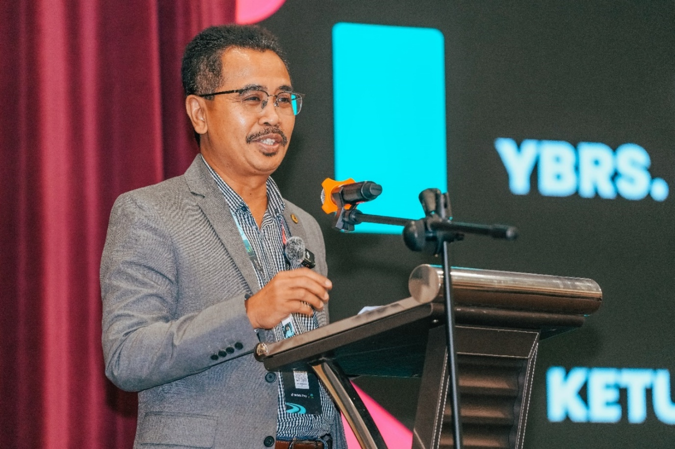
Figure 1. YBrs. En. Abdul Rashid bin Bahri, Director-General of FAMA, delivering the keynote address at the AMTTSE Grand Final Live Streaming Competition 2024, emphasising the strategic importance of digital capability development for agricultural entrepreneurs facing market uncertainty.
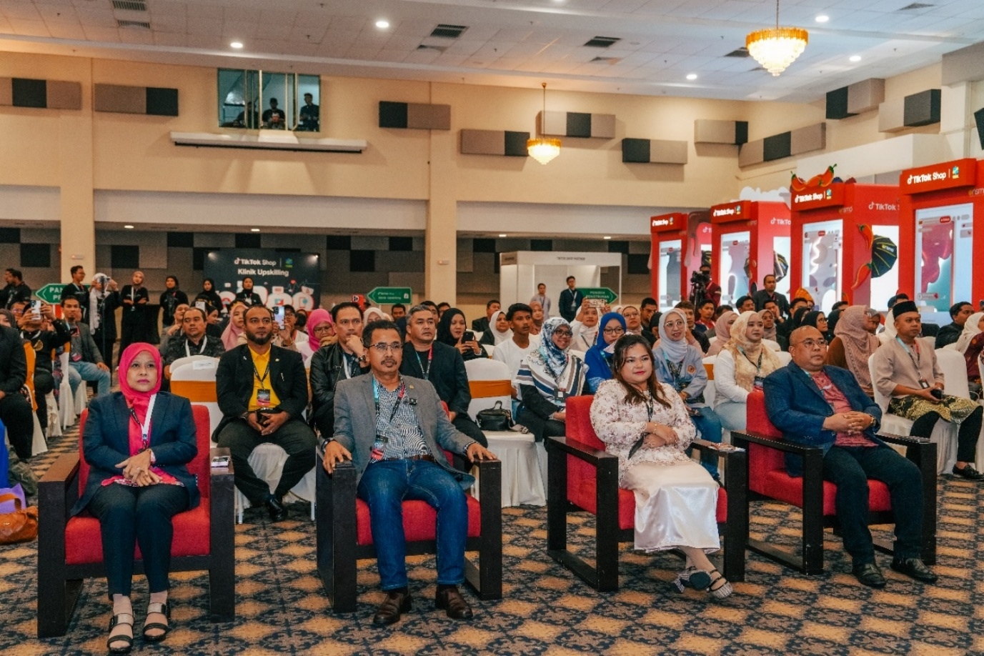
Figure 2. Distinguished guests and institutional leaders at the Closing Ceremony, including Deputy Director-Generals of FAMA and the Director of Strategic Relations, TikTok Shop Malaysia, illustrating the multi-stakeholder partnerships essential to educational innovation at scale.
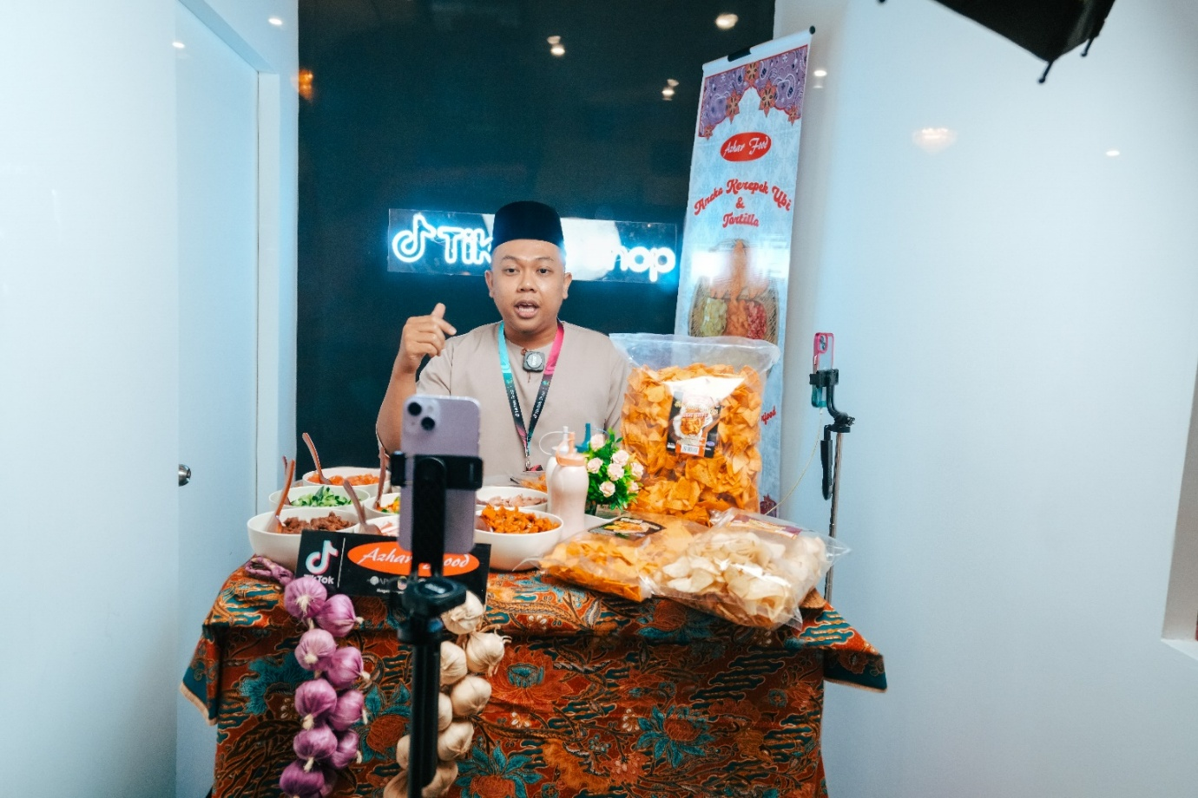
Figure 3. A top-performing company (Azhar Food) conducting a live sales session during the Grand Final. The company achieved RM1.77 million in cumulative sales, demonstrating the translation of experiential learning into sustained commercial performance.
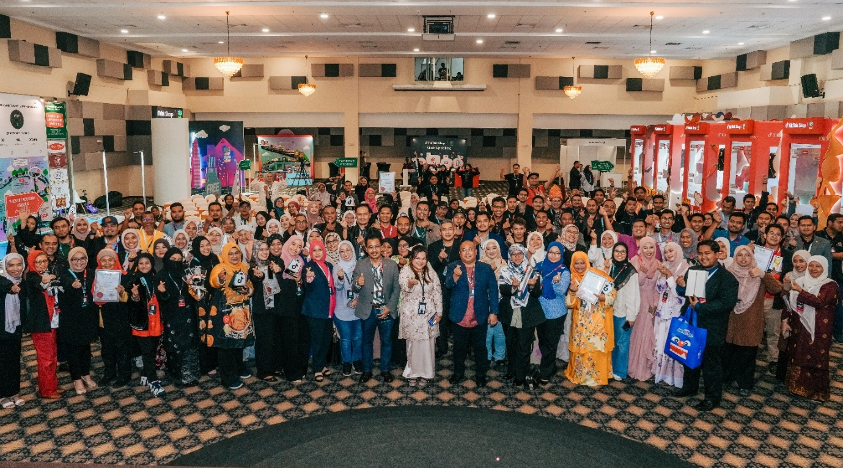
Figure 4. Programme participants posing with guests and award winners at the conclusion of the official ceremony, highlighting the communal and celebratory dimensions of the learning experience that reinforce motivation and professional identity.

Figure 5. Dapur Pak Amir, a person with disabilities and Champion of the Live Streaming Competition, receiving the award from the FAMA Director-General. This image symbolises the inclusive potential of well-designed digital entrepreneurship education.
Additional Tables
Table 4. Monthly Programme Performance, June–December 2024 (Selected Indicators)
Month | Total Sales (RM) | Livestream (RM) | Short Video (RM) | Orders
June | 1,245,000 | 412,000 | 325,000 | 18,450
July | 892,000 | 298,000 | 241,000 | 14,200
August | 1,056,000 | 351,000 | 278,000 | 16,800
September | 1,312,000 | 445,000 | 342,000 | 19,650
October | 1,489,000 | 512,000 | 389,000 | 22,100
November | 1,211,000 | 398,000 | 312,000 | 17,900
December | 1,705,942 | 589,670 | 434,255 | 24,800
Source: FAMA TikTok Shop Performance Report (2024). Note: Full monthly channel breakdowns available in source data.
Table 5. Pearson Correlation Analysis Using Monthly Aggregate Data (n = 7)
Indicator | r | p
Livestream Sales | .989 | < .0001
Short-Video Sales | .997 | < .0001
Total Orders | .977 | .0002
Products Sold | .930 | .0024
Total Content Volume | .412 | .312 (ns)
Note. ns = not significant. Correlations computed on programme-month aggregate data.
References (continued)
Chen, Y., & Wang, L. (2023). Livestream commerce as experiential learning: Evidence from Chinese agribusiness training. Journal of Interactive Marketing, 58, 112–128.
Dirkx, J. M. (2012). Self-formation and transformative learning: A response to Dirkx and Mezirow. Adult Education Quarterly, 62(2), 191–197.
Kolb, A. Y., & Kolb, D. A. (2017). Experiential learning theory as a guide for experiential educators in higher education. Experiential Learning & Teaching in Higher Education, 1(1), 7–44.
Kraus, S., Palmer, C., Kailer, N., Kallinger, F. L., & Spitzer, J. (2022). Digital entrepreneurship: A research agenda on new business models. International Journal of Entrepreneurial Behavior & Research, 28(5), 1172–1193.
Masten, A. S., & Motti-Stefanidi, F. (2020). Multisystem resilience for children and youth in disaster. Development and Psychopathology, 32(4), 1395–1409.
Menchaca, M. P., Hoffman, D. L., & Tirthali, D. (2025). Editor's introduction: Technology in Education. IAFOR Journal of Education, 13(2). https://doi.org/10.22492/ije.13.2
Nambisan, S. (2017). Digital entrepreneurship: Toward a digital technology perspective of entrepreneurship. Entrepreneurship Theory and Practice, 41(6), 1029–1055.
Teece, D. J., Pisano, G., & Shuen, A. (1997). Dynamic capabilities and strategic management. Strategic Management Journal, 18(7), 509–533.
Ungar, M. (2021). Systemic resilience: Principles and processes for a science of change in contexts of adversity. Ecology and Society, 26(3), 1–12.
Yüksek, Y. Y. (2025). Enacting youth agency in higher education: Resilience as a response to uncertainty. IAFOR Journal of Education: Studies in Education, 13(3), 55–72.
Note: This manuscript has been formatted to approximate 17 pages in the IAFOR Journal of Education house style (Times New Roman 12 pt, 1.15 line spacing, standard margins) when including title page, abstract, body text, tables, figures, and references.
The programme's success in attracting participation from 13 companies owned by persons with disabilities deserves particular attention from an educational equity perspective. Digital entrepreneurship education has the potential to lower traditional barriers related to physical mobility, location, and social capital. The championing of Dapur Pak Amir illustrates that when training is designed with accessibility and authentic practice at its core, learners who have historically been excluded from mainstream entrepreneurial pathways can achieve outstanding results. This has direct implications for the design of future programmes aiming for inclusive educational resilience.
Geographic analysis further reveals important lessons for educational access in uncertain times. While Selangor dominated participation, the presence of entrepreneurs from Kelantan, Terengganu, and even Sabah and Sarawak indicates that government-led digital programmes can achieve meaningful national reach when combined with platform partnerships and targeted recruitment. However, the lower participation rates from East Malaysia and more remote states suggest that additional logistical support, subsidised connectivity, and localised mentoring may be necessary to achieve truly equitable distribution of educational opportunity.
From a policy perspective, the AMTTSE model demonstrates the value of outcome-based public investment in digital capability development. The reported 1:31 ROI provides compelling evidence that well-designed educational interventions can generate significant economic multipliers. Policymakers should consider embedding similar structured experiential components in other sectoral reskilling initiatives, particularly those targeting smallholder farmers, informal sector workers, and other groups vulnerable to technological disruption.
Ally, M. (2022). Foundations of educational theory for online learning. In T. Anderson (Ed.), Theory and practice of online learning (3rd ed.). AU Press.
Bawden, D., & Robinson, L. (2022). Information overload: An overview. In Oxford research encyclopedia of communication. Oxford University Press.
Beetham, H. (2023). Digital capability: What is it and why it matters. JISC.
Biggs, J., & Tang, C. (2022). Teaching for quality learning at university (5th ed.). McGraw-Hill Education.
Brown, M. (2023). The digital university: A critical perspective. Critical Studies in Education, 64(2), 145–162.
Conole, G. (2023). Learning design and open education. In Open education: A practical guide. Springer.
Dabbagh, N. (2022). Pedagogical models for e-learning. In Handbook of research on educational communications and technology. Springer.
Ehlers, U. D. (2022). Quality in e-learning. In Handbook of open, distance and digital education. Springer.
Facer, K. (2023). Learning futures: Education, technology and social change. Routledge.
Garrison, D. R. (2022). Online community of inquiry. The Internet and Higher Education, 52, 100–108.

