Strategic Social Commerce Capability and Revenue Performance Among Malaysian Agropreneurs: An Institutional Orchestration Perspective on the Agromarketing Masterclass TikTok Shop Edition
Abd Razzif Abd Razak*
Faculty of Management and Economics, Universiti Pendidikan Sultan Idris
Siti Faizah Zainal
Faculty of Management and Economics, Universiti Pendidikan Sultan Idris
Siti Nurulaini Azmi
Faculty of Management and Economics, Universiti Pendidikan Sultan Idris
Nur Hafizah Roslan
Faculty of Management and Economics, Universiti Pendidikan Sultan Idris
Nur Syairah Ani
Faculty of Management and Economics, Universiti Pendidikan Sultan Idris
Corresponding Author’s Email: razzif@fpe.upsi.edu.my
Received Date: Not applicable (Leave blank)
Accepted Date: Not applicable (Leave blank)
Available Online: Not applicable (Leave blank)

ABSTRACT
Governments across emerging economies are investing heavily in social commerce training, yet scholarly understanding of how such interventions build strategic capability and translate into measurable revenue remains limited. Most evaluations still report participation counts or satisfaction scores rather than monetisation quality, seller activation, or channel conversion. This study addresses that gap by examining the Agromarketing Masterclass TikTok Shop Edition, a government-led digital transformation initiative by Malaysia’s Federal Agricultural Marketing Authority, through the lens of strategic social commerce capability and institutional orchestration. Using official archival records covering 80 participating companies, 160 entrepreneurs and seven programme months from June to December 2024, the study applies descriptive analysis, channel decomposition, seller concentration analysis and Pearson correlations to programme-level performance data. The programme generated RM6,205,957.06 in cumulative sales and an approximate return on investment of 1:30.64. Short-video and livestream channels accounted for the majority of monetised revenue, while content volume alone was not a consistent predictor of sales. Seller-level records reveal concentration effects, with the top ten sellers contributing 26.4% of total gross merchandise value and 25 sellers recording zero sales. Theoretically, the study extends resource-based, dynamic capability and institutional perspectives by distinguishing digital exposure from conversion capability and by positioning public agencies as orchestrators of platform-based revenue systems. Practically, the findings inform capability-based redesign of government digital programmes, seller segmentation strategies and inclusive entrepreneurship policy. The article is original in reframing a public-sector social commerce intervention as a strategic capability development problem rather than a programme outcome audit.
Keywords: strategic social commerce capability; institutional orchestration; agropreneur revenue performance; government-led digital transformation; SME competitiveness

INTRODUCTION
The global business environment has entered a phase in which competitive advantage depends less on physical market presence and more on the capacity to orchestrate digital customer journeys across social platforms. Social commerce has moved from an experimental channel to a mainstream revenue architecture, combining short-form video, live selling, community interaction and in-platform checkout within a single commercial environment. For small and medium-sized enterprises, this shift is strategically consequential. It lowers entry barriers to national markets, but it also raises capability requirements in content production, audience engagement, offer design, fulfilment discipline and performance analytics.
International evidence suggests that digital transformation among SMEs is uneven. Verhoef et al. (2021) argue that digitalisation reshapes business models and customer engagement, while Kraus et al. (2022) show that digital entrepreneurship is defined by new value-creation logics rather than simple technology adoption. Sahut et al. (2021) further note that entrepreneurs must continuously adapt to platform dynamics. Yet many firms still treat social media activity as visibility rather than conversion infrastructure. The implication is that digital presence alone does not guarantee revenue performance; capability must be strategically assembled.
Malaysia presents a particularly instructive context. The country has pursued sustained digital economy development, yet agropreneurs continue to face thin margins, geographic dispersion, limited marketing infrastructure and dependence on intermediaries. Public agencies have therefore experimented with structured digital market interventions that combine training, platform partnership and post-programme monitoring. One such intervention is the Agromarketing Masterclass TikTok Shop Edition, implemented by the Federal Agricultural Marketing Authority to strengthen practical selling competence on TikTok Shop. The programme is analytically valuable because it links institutional support with observable sales records rather than self-reported intentions alone.
Despite growing policy interest in social commerce, three scholarly limitations persist. First, government-led digital programmes are often assessed through participation or satisfaction metrics rather than monetisation quality. Second, studies frequently treat content activity as a proxy for performance without distinguishing exposure from conversion. Third, institutional orchestration — the role of public agencies in shaping platform-based capability — remains under-theorised in social commerce research. Mohd Noor and Afief El Ashfahany (2025) demonstrate in the Malaysian context that institutional framework influences young entrepreneurs’ digital business performance, yet their study does not examine a government social commerce intervention using official sales archives.
Against this background, the present study reframes the Agromarketing Masterclass TikTok Shop Edition as a strategic social commerce capability development problem situated within a government-led digital transformation agenda. The research gap is the limited evidence connecting institutional orchestration, strategic social commerce capability and revenue performance using administrative sales data. The significance of the study lies in its ability to inform capability-based programme design, seller segmentation and inclusive entrepreneurship policy in a developing-economy setting. The objectives are to examine the revenue structure of the programme, analyse the relationship between monetised channel indicators and sales performance, assess seller concentration and activation patterns, and develop an institutional orchestration explanation for strategic social commerce capability among Malaysian agropreneurs.

LITERATURE REVIEW

Social Commerce, SME Competitiveness and Revenue Logic
Social commerce has evolved from a promotional extension of e-commerce into a distinct commercial logic in which persuasion, entertainment and transaction occur simultaneously. Dwivedi et al. (2021) identify social and digital media marketing as a major research frontier, while Hsu and Lin (2023) show that purchase intention in social commerce is shaped by trust, community cues and platform usability. For SMEs, the strategic question is no longer whether to participate on social platforms, but how to convert participation into repeatable revenue.
Recent scholarship distinguishes between digitally active firms and digitally capable firms. Centobelli et al. (2022) demonstrate that innovative startups may appear digital while remaining weakly connected to monetisation workflows. Rippa et al. (2021) argue that digital business model innovation requires integrated capability rather than isolated tool adoption. Wang and Kim (2023) further show that seller performance in social commerce ecosystems depends on platform governance and conversion discipline. These studies collectively suggest that revenue performance is capability-dependent, not activity-dependent.

Capability, Institutional Support and Entrepreneurial Performance
The SME competitiveness literature increasingly links capability development to institutional context. Bischoff (2021) emphasises entrepreneurial ecosystems, while Fredström et al. (2021) show that institutional regulation shapes entrepreneurship productivity. Tabares et al. (2022) extend this logic to rural entrepreneurship, arguing that livelihood outcomes depend on the interaction between market access and institutional support. In Malaysia, Mohd Noor and Afief El Ashfahany (2025) find that institutional framework, need for achievement and global market orientation influence young entrepreneurs’ digital business performance. This AJoBSS evidence is directly relevant because it confirms that institutional conditions matter for digital business outcomes, but it does not explain how a public agency can orchestrate platform-based revenue creation at programme scale.
Capability research also highlights conversion rather than exposure. Mohd Yunos et al. (2025), in another AJoBSS study, show that personalization strategies influence customer engagement and retention in hyper-connected markets. Their findings imply that audience relevance and relational tailoring are central to sustained commercial performance. This insight challenges training models that emphasise content volume without conversion design.

Digital Transformation, Inclusion and Unresolved Issues
Government-led digital transformation programmes are widely promoted, yet their business effects remain inconsistently evidenced. Hanelt et al. (2021) note that digital transformation research still lacks clarity on how organisational capabilities translate into performance under institutional intervention. Giones et al. (2021) similarly call for stronger links between digitalization research and business model change. Inclusion adds another unresolved issue. Lasmini et al. (2025), writing in AJoBSS, show that financial literacy shapes fintech adoption among women entrepreneurs in Indonesia. Oggero et al. (2020) and Hasan et al. (2021) extend this argument to financial capability and inclusive finance. These studies remind us that digital transformation must be judged by access to monetisation, not only access to training.
Three unresolved issues justify the present framework. First, there is limited archival evidence on whether public-sector social commerce training produces measurable revenue and activation outcomes. Second, the literature has not sufficiently separated content exposure from conversion capability in platform selling. Third, institutional orchestration remains undertheorised as a strategic mechanism that enables SMEs to move from digital participation to revenue performance. The proposed study addresses these gaps through the Agromarketing Masterclass TikTok Shop Edition dataset.

THEORY DEVELOPMENT AND CONCEPTUAL FRAMEWORK
This study integrates Resource-Based View, Dynamic Capability Theory, Institutional Theory and the Technology-Organisation-Environment framework into a single explanatory logic centred on strategic social commerce capability. RBV explains why certain seller competencies — persuasive storytelling, livestream execution, offer timing, customer response and storefront management — can function as valuable, rare and difficult-to-imitate resources in crowded platform markets (Barney, 1991). Dynamic Capability Theory extends this view by emphasising that these resources must be continually reconfigured as platform algorithms, content competition and consumer attention shift (Teece, 2018; Mikalef et al., 2020).
Institutional Theory adds the policy dimension. Public agencies do not merely fund training; they shape rules of participation, reduce uncertainty, provide implementation support and influence how entrepreneurs interpret platform opportunities. The TOE framework helps organise this logic: technology refers to TikTok Shop functions and analytics; organisation refers to seller skill, mindset and workflow discipline; environment refers to FAMA support, market access conditions and platform partnership structures.
The central construct is strategic social commerce capability, defined here as the integrated ability to design, execute and adapt monetisation-oriented social commerce activities across content, engagement and transaction pathways. This construct differs from generic digital literacy because it is explicitly revenue-oriented. It also differs from platform exposure because it emphasises conversion discipline. Mohd Yunos et al. (2025) support this distinction by showing that engagement strategies must be personalised and commercially relevant to retain customers in hyper-connected markets.
The framework proposes that strategic social commerce capability influences conversion intensity, defined as the programme’s capacity to transform platform interactions into orders and sales across monetised channels. Conversion intensity, in turn, is expected to influence revenue performance. Institutional orchestration — the structured support provided by FAMA through training, monitoring, platform partnership and post-programme guidance — is expected to moderate the relationship between capability and conversion intensity because institutional support reduces execution risk and accelerates learning.
Figure 1 presents the conceptual framework. The hypotheses are as follows:
H1: Strategic social commerce capability is positively associated with conversion intensity.
H2: Conversion intensity is positively associated with revenue performance.
H3: Monetised channel activity is more strongly associated with revenue performance than raw content volume.
H4: Institutional orchestration strengthens the relationship between strategic social commerce capability and conversion intensity.
H5: Seller activation is uneven, such that revenue performance is concentrated among entrepreneurs with stronger conversion capability.
H6: Inclusion outcomes depend on capability access rather than programme participation alone.
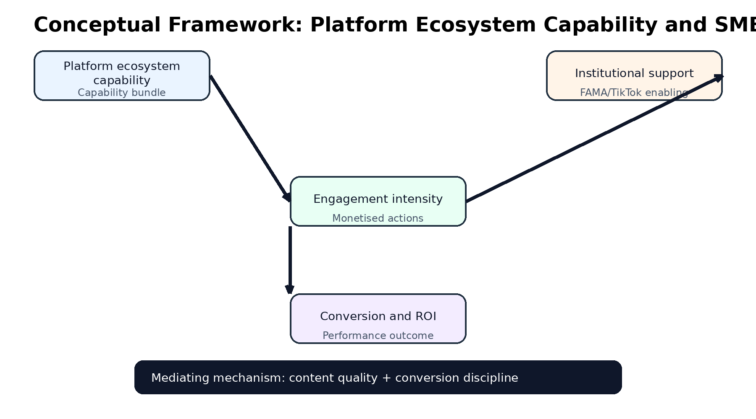
Figure 1. Conceptual framework linking strategic social commerce capability, institutional orchestration, conversion intensity and revenue performance
Figure 1. Conceptual framework linking strategic social commerce capability, institutional orchestration, conversion intensity and revenue performance.

RESEARCH METHODOLOGY

Research Philosophy and Design
The study adopts a post-positivist research philosophy and a quantitative archival research design. The logic is appropriate because the available evidence consists of administrative programme records rather than primary survey responses. The purpose is not to claim causal identification beyond the available data, but to interpret how official performance records reveal patterns of strategic social commerce capability, conversion intensity and revenue concentration.

Data Source and Sampling
The data source is the official Projek Perintis Report (December 2024) for the Agromarketing Masterclass TikTok Shop Edition, supplemented by seller-level gross merchandise value records. The dataset covers 80 participating companies, 160 entrepreneurs, 425 stock keeping units and monthly performance records from June to December 2024. May 2024 appears as a baseline month and is excluded from the main correlation analysis to preserve consistency with the stated programme period. The unit of seller-level descriptive analysis is the company, while the unit of aggregate correlational analysis is the monthly programme record.

Variables and Measurement
The dependent variable for aggregate analysis is total monthly sales in Malaysian Ringgit. Independent indicators include livestream sales, short-video sales, profile-window sales, shop-tab sales, orders, products sold, live-stream content volume, short-video content volume, total content volume and products for sale. Additional descriptive indicators include number of companies, number of entrepreneurs, persons-with-disabilities-owned firms and top-seller concentration. Variables are measured using official programme reporting categories from the Summary and Seller GMV sheets.

Analytical Procedures
The study uses descriptive statistics, channel decomposition, geographic distribution analysis, seller concentration analysis and Pearson correlation analysis. Numerical consistency checks were conducted by comparing monthly totals with channel summaries and seller-level aggregates. Significance is reported at p < .05 and p < .01.

Validity, Reliability and Ethics
Validity is strengthened by the use of official administrative records rather than recalled performance data. Reliability is supported by the structured reporting format used across all programme months. Ethics approval was not required because the study uses secondary official data without personal identifiers. This position is consistent with the AJoBSS ethics requirements for non-interventional archival research.

FINDINGS

Programme Profile and Revenue Scale
Table 1 summarises the programme profile. The Agromarketing Masterclass TikTok Shop Edition involved 80 companies and 160 entrepreneurs, with 425 stock keeping units marketed through TikTok Shop. Thirteen companies were owned by persons with disabilities, indicating an inclusion dimension within the programme design. Cumulatively, the programme generated RM6,205,957.06 in sales between June and December 2024 and achieved an approximate return on investment of 1:30.64. These figures indicate that the intervention produced measurable economic returns rather than symbolic digital participation alone.
Indicator | Value
Participating companies | 80
Participating entrepreneurs | 160
Stock keeping units marketed | 425
Persons-with-disabilities-owned companies | 13
Training cohorts delivered | 2
Cumulative sales (June–December 2024) | RM6,205,957.06
Return on investment | 1:30.64
Table 1. Programme profile of the Agromarketing Masterclass TikTok Shop Edition, June to December 2024.
Source: Projek Perintis Report (December 2024).

Channel Decomposition and Conversion Logic
Table 2 presents sales by monetised channel. Short-video sales contributed RM2,766,229.44 (44.6%), livestream sales contributed RM2,199,951.99 (35.4%), shop-tab sales contributed RM1,112,755.54 (17.9%) and profile-window sales contributed RM127,020.07 (2.0%). The pattern indicates that revenue was concentrated in interactive and content-led channels rather than passive storefront presence. From a capability perspective, the highest-performing entrepreneurs appear to have treated short video and livestreaming as conversion mechanisms rather than as visibility tools.
Channel | Sales (RM) | Share (%)
Short video | 2,766,229.44 | 44.6
Livestream | 2,199,951.99 | 35.4
Shop tab / others | 1,112,755.54 | 17.9
Profile / window | 127,020.07 | 2.0
Total | 6,205,957.06 | 100.0
Table 2. Sales value by TikTok Shop channel, June to December 2024.
Source: Projek Perintis Report (December 2024), Summary sheet.
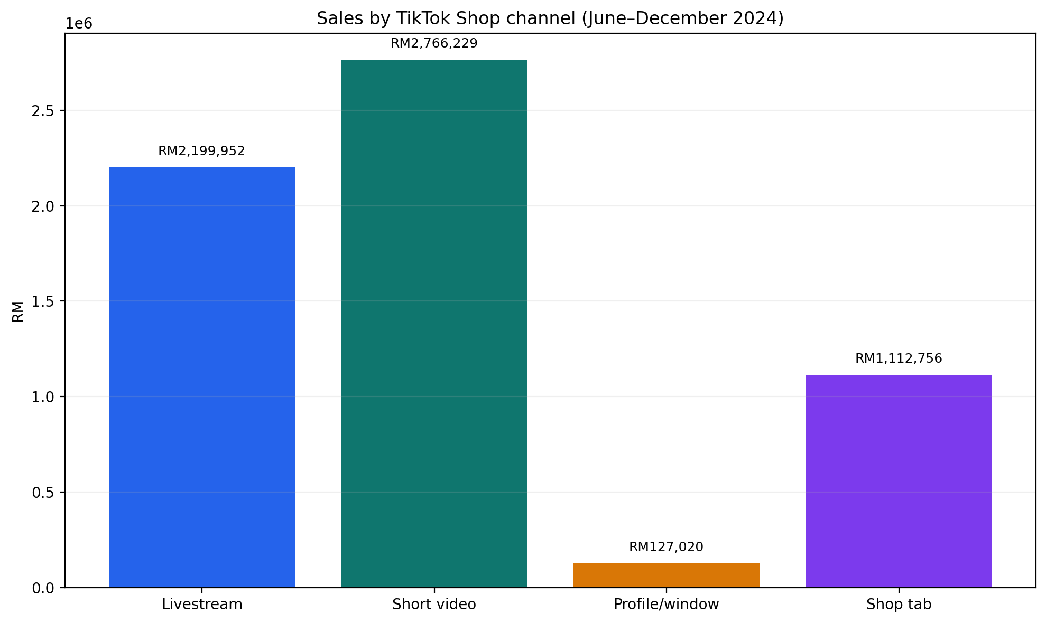
Figure 2. Distribution of sales by monetised TikTok Shop channel
Figure 2. Distribution of sales by monetised TikTok Shop channel.

Geographic Participation and Market Access
Table 3 shows the geographic distribution of participating companies. Selangor recorded the highest participation with 33 companies (41.3%), followed by Perak and Kelantan with eight companies each (10.0%). States such as Perlis, Melaka, Sabah and Sarawak recorded only one company each (1.3%). The distribution suggests that programme uptake reflected existing digital readiness and entrepreneurial density, while still attracting participants from multiple regions. This pattern is relevant to institutional orchestration because public agencies must balance nationwide inclusion with differentiated post-training support.
No. | State | Companies (n) | Share (%)
1 | Perlis | 1 | 1.3
2 | Kedah | 3 | 3.8
3 | Penang | 2 | 2.5
4 | Perak | 8 | 10.0
5 | Kuala Lumpur | 6 | 7.5
6 | Selangor | 33 | 41.3
7 | Negeri Sembilan | 5 | 6.3
8 | Melaka | 1 | 1.3
9 | Johor | 4 | 5.0
10 | Pahang | 3 | 3.8
11 | Kelantan | 8 | 10.0
12 | Terengganu | 4 | 5.0
13 | Sabah | 1 | 1.3
14 | Sarawak | 1 | 1.3
 | Total | 80 | 100.0
Table 3. Distribution of participating companies by state.
Source: FAMA TikTok Shop Performance Report (2024).

Monthly Revenue Accumulation
Table 4 reports monthly programme performance. Total sales rose from RM497,762.95 in June to RM1,705,942.05 in December, representing a 242.7% increase over the monitoring period. Orders and products sold followed a similar upward trajectory. The trend suggests capability accumulation over time rather than a one-off campaign effect. This is consistent with dynamic capability logic: entrepreneurs learned, adjusted and reconfigured their selling practices as they gained platform experience under institutional monitoring.
Month | Total Sales (RM) | Livestream (RM) | Short Video (RM) | Products Sold | Orders
June | 497,762.95 | 194,759.55 | 180,940.23 | 21,280 | 3,271
July | 507,967.92 | 174,190.65 | 193,101.29 | 22,298 | 3,381
August | 728,225.46 | 259,453.12 | 300,783.08 | 34,583 | 4,645
September | 692,259.02 | 263,009.12 | 263,940.70 | 25,617 | 7,159
October | 814,482.14 | 323,530.03 | 317,551.16 | 32,334 | 6,164
November | 1,259,317.52 | 402,162.25 | 638,313.61 | 37,804 | 10,194
December | 1,705,942.05 | 582,847.27 | 871,599.37 | 45,192 | 14,571
Table 4. Monthly programme performance, June to December 2024.
Source: Projek Perintis Report (December 2024), Summary sheet.
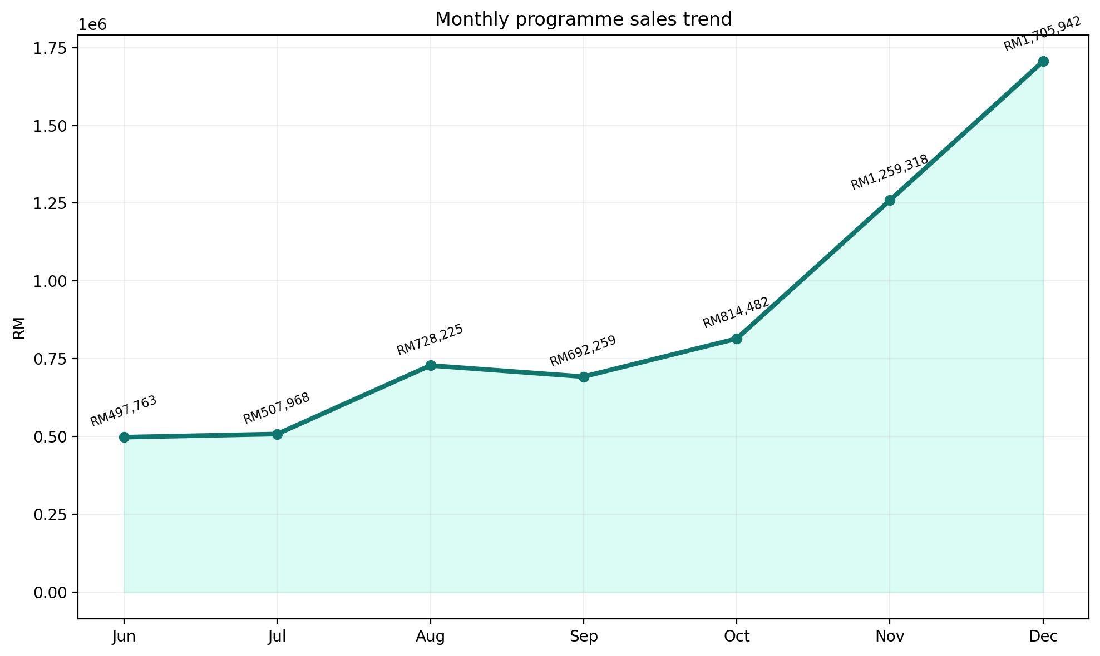
Figure 3. Monthly sales trend across the programme period
Figure 3. Monthly sales trend across the programme period.

Seller Concentration and Activation
Table 5 presents the top ten sellers by gross merchandise value. The leading seller, Chef Ustazah HQ, recorded RM689,517.94, followed by kerepek azharfood with RM533,945.85. Collectively, the top ten sellers generated RM1,637,490.22, equivalent to 26.4% of total programme sales. At the same time, 55 sellers recorded positive gross merchandise value while 25 sellers recorded zero gross merchandise value in the seller-level reporting period. The programme therefore created real value, but that value was unevenly distributed. This supports H5 and has direct managerial implications: aggregate success can mask inactive sellers.
Rank | Shop Name | GMV (RM)
1 | Chef Ustazah HQ | 689,517.94
2 | kerepek azharfood | 533,945.85
3 | Munif Cocoa @ Koko Spread Sedap | 173,804.07
4 | DASTO HQ | 107,254.26
5 | Dapur Pak Amir | 39,562.30
6 | Baja Taiping | 37,368.97
7 | Ayamhalalbismi | 20,120.58
8 | RIZQ MART | 15,701.73
9 | Corndog Anak Ramai HQ | 10,396.60
10 | agromasmalaysia | 9,817.92
Table 5. Top ten sellers by gross merchandise value.
Source: Projek Perintis Report (December 2024), Seller GMV sheet.

Correlation Analysis and Capability Interpretation
Table 6 reports Pearson correlations between monthly indicators and total sales. Short-video sales (r = .997, p < .0001), livestream sales (r = .989, p < .0001), orders (r = .977, p = .0002), shop-tab sales (r = .972, p = .0002), profile-window sales (r = .971, p = .0003) and products sold (r = .930, p = .0024) were all strongly and positively associated with total monthly sales. By contrast, short-video content volume (r = .414, p = .3556), total content volume (r = .538, p = .2133) and products for sale (r = -.011, p = .9807) were not statistically significant. Live-stream content volume showed a positive but marginal association (r = .720, p = .0683).
Indicator | Pearson r | p-value | Significance
Short-video sales (RM) | .997 | <.0001 | **
Livestream sales (RM) | .989 | <.0001 | **
Orders | .977 | .0002 | **
Shop-tab sales (RM) | .972 | .0002 | **
Profile/window sales (RM) | .971 | .0003 | **
Products sold | .930 | .0024 | **
Live-stream content volume | .720 | .0683 | ns
Short-video content volume | .414 | .3556 | ns
Total content volume | .538 | .2133 | ns
Products for sale | -.011 | .9807 | ns
Table 6. Pearson correlation analysis using monthly aggregate programme data (n = 7).
Note: ** p < .01; ns = not significant. Source: Author calculation based on Projek Perintis Report (December 2024).
The correlation pattern supports H3 directly. Monetised channel activity aligns with revenue performance far more consistently than raw content volume. In strategic terms, the programme’s strongest returns were associated with conversion intensity rather than publishing intensity.

DISCUSSION
The findings should be interpreted as evidence of capability formation under institutional orchestration rather than as proof of uniform programme success. The Agromarketing Masterclass TikTok Shop Edition generated substantial sales, but the more important insight is how those sales were produced. Revenue was concentrated in short-video and livestream channels, monthly performance strengthened over time, and seller-level records reveal both activation and concentration. These patterns align with the study’s theoretical expectation that strategic social commerce capability — not mere platform exposure — drives revenue performance.
Comparison with AJoBSS scholarship sharpens this interpretation. Mohd Noor and Afief El Ashfahany (2025) show that institutional framework influences young entrepreneurs’ digital business performance in Malaysia. The present study extends that insight by demonstrating what institutional support can produce when it is linked to a platform-specific intervention with monitored sales records. The contribution is no longer abstract; it is observable in channel sales, order growth and seller activation. Lasmini et al. (2025) highlight the role of capability in fintech adoption among women entrepreneurs. The current findings resonate with that argument because inclusion in the programme — including participation by persons-with-disabilities-owned firms — only becomes socially meaningful when capability leads to monetisation. Participation without conversion does not constitute inclusive entrepreneurship.
The results also refine international social commerce research. Dwivedi et al. (2021) and Hsu and Lin (2023) emphasise trust, engagement and platform experience as drivers of social commerce behaviour. The present study adds an outcome-oriented qualification: engagement metrics matter only when they are connected to monetised channel design. Mohd Yunos et al. (2025) show that personalization strategies improve retention in hyper-connected markets. In the Agromarketing Masterclass TikTok Shop Edition context, the analogue of personalization is conversion-oriented content and livestream execution tailored to product category, audience and offer structure. Yahaya (2025) further demonstrates that engagement can strengthen brand equity when strategically managed. The seller concentration observed here suggests that some entrepreneurs achieved that strategic management more effectively than others.
From a dynamic capability perspective, the monthly sales trajectory is especially informative. The programme did not produce a flat post-training spike followed by decline. Instead, sales accumulated across months, suggesting that entrepreneurs learned to reconfigure content themes, livestream timing and offer bundles. This is consistent with Teece (2018) and Mikalef et al. (2020), who argue that capability renewal is central to performance in changing digital environments. From an institutional perspective, FAMA’s role appears to have reduced uncertainty and created a structured environment in which experimentation could occur. Amran et al. (2025) show that strategic management and cost effectiveness matter under competitive pressure. In this programme, the relevant cost is not only financial input but also the opportunity cost of weak conversion capability.
The study also challenges policy reporting practices. A headline figure of RM6.2 million in cumulative sales is impressive, but policy interpretation becomes more accurate when accompanied by activation rates, seller segmentation and channel composition. Without those indicators, public agencies risk overestimating programme reach while underestimating the support required by inactive sellers. This is the main managerial implication of the seller concentration results.

THEORETICAL CONTRIBUTIONS
The study makes four theoretical contributions. First, it extends RBV by distinguishing exposure resources from conversion resources in social commerce. A seller may possess products, content and storefront presence without possessing strategic social commerce capability. Second, it extends dynamic capability theory by showing that adaptation in platform selling is sequential and channel-specific rather than generic. Third, it advances institutional theory by conceptualising public agencies as orchestrators of platform-based revenue systems rather than as passive training providers. Fourth, it contributes to social commerce scholarship by introducing conversion intensity as a programme-level mediator between capability and revenue performance.

PRACTICAL CONTRIBUTIONS
For SMEs and entrepreneurs, the central lesson is that content quality, offer design, response speed and livestream execution matter more than frequent posting alone. For FAMA and similar agencies, the programme should be continued but sharpened through seller segmentation, post-masterclass conversion clinics, analytics dashboards and channel-specific coaching. High performers require scaling support in inventory readiness and campaign planning. Moderate performers need conversion coaching on offer design and livestream technique. Inactive sellers require diagnostic review before additional training is deployed.
For TikTok Shop and other platform providers, the evidence suggests that partnership models should support merchant conversion workflows, not only traffic generation. For policymakers, the study demonstrates that government-led digital transformation can produce measurable returns when training is integrated with platform access, monitoring and monetisation design. The appropriate evaluation metrics are channel sales, orders, activation rates, seller-level gross merchandise value and return on investment — not attendance counts alone.

SOCIAL CONTRIBUTIONS
The social contribution lies in inclusive and rural economic development. The programme involved entrepreneurs from multiple states, including less commercially central regions, and included persons-with-disabilities-owned firms. This indicates that social commerce can widen market access when institutional orchestration lowers barriers to platform participation. However, inclusion must be measured by monetisation opportunity, not by enrollment alone. The study therefore supports a capability-based inclusion agenda in government digital policy.

CONCLUSION
This study examined the Agromarketing Masterclass TikTok Shop Edition as a strategic social commerce capability intervention within a government-led digital transformation agenda. Using official archival data, it showed that the programme generated RM6,205,957.06 in cumulative sales and an approximate return on investment of 1:30.64 between June and December 2024. The strongest revenue drivers were monetised short-video and livestream channels, while content volume alone was not a reliable predictor of sales. Seller-level analysis further revealed concentration and activation gaps, with the top ten sellers accounting for 26.4% of total sales and 25 sellers recording zero gross merchandise value.
Theoretically, the study extends resource-based, dynamic capability and institutional perspectives by showing that public-sector social commerce programmes must be understood as capability orchestration systems. Managerially, the findings support a shift from training completion metrics to conversion-oriented post-programme support. The main limitation is the archival and aggregate nature of the dataset, which restricts causal inference and seller-level modelling of engagement quality. Future research should incorporate seller-level longitudinal analytics, profit measures, livestream conversion rates and experimental programme designs to strengthen causal claims.

ETHICS STATEMENT
This study used secondary official programme records and did not involve direct interaction with human participants. No personal identifiers were used in the analysis. Ethics approval was therefore not required for this archival research.

AUTHOR CONTRIBUTIONS
Abd Razzif Abd Razak: conceptualisation, methodology, formal analysis, writing — original draft, writing — review and editing, supervision, project administration.
Siti Faizah Zainal: conceptualisation, validation, data curation, visualisation, project administration.
Siti Nurulaini Azmi: methodology, validation, resources, writing — review and editing, supervision.
Nur Hafizah Roslan: formal analysis, investigation, software, writing — review and editing.
Nur Syairah Ani: formal analysis, investigation, software, writing — review and editing.

ACKNOWLEDGEMENTS
The authors thank the Federal Agricultural Marketing Authority, TikTok Shop Malaysia and the participating entrepreneurs for making the programme records available for academic analysis. No external research funding was received for this study.

DECLARATION OF INTERESTS
The authors declare no known competing financial interests or personal relationships that could have appeared to influence the work reported in this article.

REFERENCES
Amran, W. S. H., Dakian, M., & Islam, G. M. N. (2025). A study on strategic management, competition, and cost effective: Analysing their combined impact on performance in Malaysia’s Grade 1 construction industry. Academic Journal of Business and Social Sciences, 9(1), 126-149.
Aksom, H. (2023). Entropy and institutional theory. International Journal of Organizational Analysis, 31(7), 3070-3093. https://doi.org/10.1108/IJOA-01-2022-0025
Alshurideh, M., Gasaymeh, A., & Ahmed, G. (2021). Loyalty program effectiveness: Theoretical reviews and practical proofs. Uncertain Supply Chain Management, 9(3), 599-612. https://doi.org/10.5267/j.uscm.2021.3.006
Barney, J. (1991). Firm resources and sustained competitive advantage. Journal of Management, 17(1), 99-120. https://doi.org/10.1177/014920639101700108
Bischoff, K. (2021). A study on the perceived strength of sustainable entrepreneurial ecosystems on the dimensions of stakeholder theory and culture. Small Business Economics, 56, 1121-1140. https://doi.org/10.1007/s11187-019-00184-6
Bouwman, H., Nikou, S., Molina-Castillo, F. J., & de Reuver, M. (2021). The impact of digital platforms on business and management research. Electronic Markets, 31(4), 723-735. https://doi.org/10.1007/s12525-021-00487-4
Centobelli, P., Cerchione, R., Esposito, E., Passaro, R., & Quinto, I. (2022). The undigital behavior of innovative startups: Empirical evidence and taxonomy of digital innovation strategies. International Journal of Entrepreneurial Behaviour & Research, 28(9), 219-241. https://doi.org/10.1108/IJEBR-10-2021-0880
Chen, C., Huang, Y., & Wu, S. (2023). How do institutional environment and entrepreneurial cognition drive female and male entrepreneurship from a configuration perspective? Gender in Management, 38(5), 653-668. https://doi.org/10.1108/GM-09-2022-0255
Cordier, I., & Bade, M. (2023). The relationship between business regulation and nascent and young business entrepreneurship revisited. Small Business Economics, 61(2), 587-616. https://doi.org/10.1007/s11187-022-00638-4
Creswell, J. W., & Creswell, J. D. (2018). Research design: Qualitative, quantitative, and mixed methods approaches (5th ed.). SAGE.
Department of Statistics Malaysia. (2023). Age group. https://statsgeo.mycensus.gov.my/geostats/mapv2.php
Dwivedi, Y. K., Ismagilova, E., Hughes, D. L., Carlson, J., Filieri, R., Jacobson, J., Jain, V., Karjaluoto, H., Kefi, H., Krishen, A. S., Kumar, V., Luo, Y., Misirlis, N., Mogaji, E., Raman, R., Rauschnabel, P. A., Rowley, J., Salo, J., & Wang, Y. (2021). Setting the future of digital and social media marketing research: Perspectives and research propositions. International Journal of Information Management, 59, 102168. https://doi.org/10.1016/j.ijinfomgt.2020.102168
FAMA. (2024). Projek Perintis Report (December 2024): Agromarketing Masterclass TikTok Shop Edition performance dataset.
Fredström, A., Peltonen, J., & Wincent, J. (2021). A country-level institutional perspective on entrepreneurship productivity: The effects of informal economy and regulation. Journal of Business Venturing, 36(5), 106002. https://doi.org/10.1016/j.jbusvent.2021.106002
Giones, F., Brem, A., Berger, E. S. C., & Bocken, N. M. P. (2021). Four avenues of digitalization research for the next decade. Digital Business, 1(1), 100014. https://doi.org/10.1016/j.digbus.2021.100014
Hair, J. F., Black, W. C., Babin, B. J., & Anderson, R. E. (2022). Multivariate data analysis (8th ed.). Cengage.
Hanelt, A., Bohnsack, R., Marz, D., & Marante, C. (2021). A systematic review of the literature on digital transformation: Insights and implications for strategy and organizational change. Journal of Management Studies, 58(5), 1159-1197. https://doi.org/10.1111/joms.12639
Hasan, M., Le, T., & Hoque, A. (2021). How does financial literacy impact on inclusive finance? Financial Innovation, 7(1), 40. https://doi.org/10.1186/s40854-021-00249-z
Hsu, C. L., & Lin, J. C. C. (2023). Social commerce constructs and consumer purchase intention: A review and future research agenda. Internet Research, 33(2), 513-542. https://doi.org/10.1108/INTR-03-2021-0210
Kraus, S., Palmer, C., Kailer, N., Kallinger, F. L., & Spitzer, J. (2022). Digital entrepreneurship: A research agenda on new business models for the twenty-first century. International Journal of Entrepreneurial Behavior & Research, 28(5), 1172-1193. https://doi.org/10.1108/IJEBR-10-2021-0881
Lasmini, R. S., Bakar, M. H., Rahim, H., & Mohd Rafien, N. S. (2025). The role of financial literacy on financial technology for women entrepreneurs in Indonesia. Academic Journal of Business and Social Sciences, 9(1), 20-35.
Li, F. (2020). The digital transformation of business models in the creative industries: A holistic framework and emerging trends. Technovation, 92-93, 102012. https://doi.org/10.1016/j.technovation.2017.12.004
Liñán, F., Paul, J., & Fayolle, A. (2020). SMEs and entrepreneurship in the era of globalization: Advances and theoretical approaches. Small Business Economics, 55, 695-703. https://doi.org/10.1007/s11187-020-00332-4
Lusardi, A., & Mitchell, O. S. (2014). The economic importance of financial literacy: Theory and evidence. Journal of Economic Literature, 52(1), 5-44. https://doi.org/10.1257/jel.52.1.5
Mikalef, P., Krogstie, J., Pappas, I. O., & Pavlou, P. A. (2020). Investigating the effects of big data analytics capabilities on firm performance: The mediating role of dynamic capabilities. Information & Management, 57(2), 103169. https://doi.org/10.1016/j.im.2019.103169
Mohd Noor, N. H., & Afief El Ashfahany. (2025). Young entrepreneurs’ digital business performance in Malaysia: Examining the influence of institutional framework, need for achievement, and global market orientation. Academic Journal of Business and Social Sciences, 9(1), 104-125.
Mohd Yunos, S. R., Sanusi, S., & Dakian, M. (2025). A study on influences of personalization strategies for engaging and retaining customers of a hyper-connected in Malaysia. Academic Journal of Business and Social Sciences, 9(1), 150-173.
Nambisan, S. (2017). Digital entrepreneurship: Toward a digital technology perspective of entrepreneurship. Entrepreneurship Theory and Practice, 41(6), 1029-1055. https://doi.org/10.1111/etap.12254
OECD. (2020). Financial literacy and the digitalisation of financial services. OECD Publishing. https://doi.org/10.1787/8b0858c5-en
Oggero, N., Rossi, M. C., & Ughetto, E. (2020). Entrepreneurial spirits in women and men: The role of financial literacy and digital skills. Small Business Economics, 55, 313-327. https://doi.org/10.1007/s11187-019-00184-6
Pappas, I. O., Kourouthanassis, P. E., Giannakos, M. N., & Lekakos, N. (2021). Social commerce and the mobile platform: Payment and security perceptions. Electronic Commerce Research, 21(2), 343-365. https://doi.org/10.1007/s10660-019-09348-5
Pappas, N., & Kourouthanassis, P. E. (2021). The role of social and cultural factors in social commerce adoption. Journal of Retailing and Consumer Services, 60, 102488. https://doi.org/10.1016/j.jretconser.2021.102488
Putit, L., Hamzah, M. I., Abdullah, M. F., Syed Annuar, S. N., & Yulianto, A. (2025). Drivers of social media marketing continuance among MSMEs in emerging economies. Journal of International Business, Economics and Entrepreneurship, 10(2), 86-97. https://doi.org/10.24191/jibe.v10i2.8743
Raub, S., Tan, P.-L., & Md Isa, A. (2025). Strategic marketing and digital transformation for SME empowerment: A Malaysia-Indonesia service-learning collaboration. Journal of International Business, Economics and Entrepreneurship, 10(2), 45-58. https://doi.org/10.24191/jibe.v10i2.8741
Rippa, P., Secundo, G., & Cerchione, R. (2021). Digital business model innovation in SMEs: An integrated framework. Journal of Business Research, 123, 683-694. https://doi.org/10.1016/j.jbusres.2020.10.014
Sahut, G., Iandoli, L., & Teulon, F. (2021). The age of digital entrepreneurship. Small Business Economics, 56, 1159-1169. https://doi.org/10.1007/s11187-019-00260-9
Seldal, T. R., & Nyhus, E. K. (2022). Financial literacy and risk behavior: A study of Norwegian high school students. Journal of Consumer Affairs, 56(1), 1-25. https://doi.org/10.1111/joca.12345
Sorescu, A. B., Frambach, R. T., Singh, J., Rangaswamy, A., & Bridges, C. (2021). Innovations in retail business models. Journal of Retailing, 97(1), 5-16. https://doi.org/10.1016/j.jretai.2020.11.001
Sunyaev, A., Kannengießer, N., Beck, R., Treiblmaier, H., Lacity, M., Kranz, J., Fridgen, G., Spankowski, U., & Luckow, A. (2021). Token economy. Business & Information Systems Engineering, 63(4), 457-478. https://doi.org/10.1007/s12599-021-00684-1
Tabares, A., Londoño-Pineda, A., Cano, J. A., & Gómez-Montoya, R. (2022). Rural entrepreneurship: An analysis of current and emerging issues from the sustainable livelihood framework. Economies, 10(6), 142. https://doi.org/10.3390/economies10060142
Teece, D. J. (2018). Business models and dynamic capabilities. Long Range Planning, 51(1), 40-49. https://doi.org/10.1016/j.lrp.2016.06.007
Thompson, N. A., & Illes, E. (2021). Entrepreneurial learning as practice: A video-ethnographic analysis. International Journal of Entrepreneurial Behaviour & Research, 27(3), 579-599. https://doi.org/10.1108/IJEBR-06-2020-0378
UNCTAD. (2023). Digital economy report 2023. United Nations Conference on Trade and Development.
Verhoef, P. C., Broekhuizen, T., Bart, Y., Bhattacharya, A., Dong, J. Q., Fabian, N., & Haenlein, M. (2021). Digital transformation: A multidisciplinary reflection and research agenda. Journal of Business Research, 122, 889-901. https://doi.org/10.1016/j.jbusres.2019.09.022
Vial, G. (2019). Understanding digital transformation: A review and a research agenda. The Journal of Strategic Information Systems, 28(2), 118-144. https://doi.org/10.1016/j.jsis.2019.01.003
Wang, Y., & Kim, Y. (2023). Platform governance and seller performance in social commerce ecosystems. Journal of Business Research, 160, 113756. https://doi.org/10.1016/j.jbusres.2023.113756
World Economic Forum. (2020). Global gender gap report 2020. World Economic Forum.
Yahaya, A. R. (2025). Bridging social exchange and engagement theory: Enhancing franchise brand equity through leadership mediation. Academic Journal of Business and Social Sciences, 9(1), 36-53.
Yau, P. C. Y., & Wong, D. (2022). Powering financial literacy through blockchain and gamification: How digital transformation impacts fintech education. In Lecture Notes in Networks and Systems (Vol. 358, pp. 45-58). Springer. https://doi.org/10.1007/978-3-030-96367-4_5
Zhang, R., Samsu, S. H., & Wong, S. Y. (2025). University-rural partnership framework: A systematic approach to sustainable rural development through higher education engagement. Academic Journal of Business and Social Sciences, 9(1), 215-228.
Zhu, G., Li, H., Li, A., & He, L. (2022). How do digital capabilities affect firm performance? The mediating role of digital innovation. Research Policy, 51(9), 104520. https://doi.org/10.1016/j.respol.2022.104520

