Digital Entrepreneurial Capability and Platform Monetisation in an Agropreneurship Programme
Abd Razzif Abd Razak, Siti Faizah Zainal, Siti Nurulaini Azmi, Nur Hafizah Roslan, Nur Syairah Ani
Universiti Pendidikan Sultan Idris, Perak, Malaysia
Corresponding author: razzif@fpe.upsi.edu.my
Abstract
This study examines the Agromarketing Masterclass TikTok Shop Edition as a case of digital entrepreneurial capability development in an ASEAN agropreneurship context. Rather than treating the programme as a simple training evaluation, the article reframes it as a platform entrepreneurship intervention in which entrepreneurs learn to recognise commercial opportunities, convert attention into orders, and build repeatable selling routines within TikTok Shop. Using official FAMA programme records for June to December 2024, the study analyses 80 participating companies, 160 entrepreneurs, 425 SKUs, monthly channel sales, seller GMV and aggregate programme performance. Descriptive analysis shows cumulative sales of RM6,205,957.06 and an ROI of approximately 1:31. Channel-level evidence indicates that short-video sales and livestream sales accounted for the largest monetised shares, while monthly trend data show strong scaling toward the final programme months. Pearson correlations using monthly aggregate data indicate that total monthly sales are strongly associated with short-video sales, livestream sales, orders and products sold, whereas content volume alone is not a reliable predictor of performance. The article contributes to entrepreneurship scholarship by positioning public-sector social commerce as a digital entrepreneurial capability mechanism rather than a promotional exercise. The findings are relevant to ASEAN entrepreneurs, SME support agencies and platform-based training providers seeking to design capability-building interventions that produce measurable commercial outcomes.
Keywords: digital entrepreneurial capability; platform entrepreneurship; social commerce; agropreneurship; ASEAN SMEs; monetisation

1. Introduction
Digital entrepreneurship has moved from a peripheral theme to a central concern in contemporary entrepreneurship research. Across ASEAN, small firms increasingly rely on platform-based discovery, social commerce and digital fulfilment to reach geographically dispersed customers. Yet many digital initiatives still measure success through participation counts, satisfaction scores or training completion rather than through entrepreneurial outcomes such as orders, conversion rates, repeat sales and seller-level monetisation. This gap matters because entrepreneurship is not simply about being online; it is about converting resources, attention and market access into value creation.
The Agromarketing Masterclass TikTok Shop Edition offers an unusually rich case for examining this shift. Implemented by the Federal Agricultural Marketing Authority (FAMA), the programme combined digital marketing coaching, livestream practice, short-video selling, content production and post-training monitoring for agropreneurs. The dataset available in the source programme report provides sales by channel, monthly performance, seller GMV and geographic coverage. These records allow the programme to be analysed as a real entrepreneurship intervention in which platform learning is linked to measurable economic outcomes.
In the broader literature, digital entrepreneurship is often discussed in relation to opportunity recognition, entrepreneurial learning, platform ecosystems and innovation capability. However, less is known about how these capabilities develop in public-sector, practice-based settings where entrepreneurs are expected to sell, iterate and adapt inside a live platform environment. The present study addresses that gap by using the FAMA programme to explore how digital entrepreneurial capability translates into platform monetisation. The paper asks a simple but important question: what forms of entrepreneurial capability matter most when social commerce becomes the main marketplace?
The research gap is threefold. First, existing studies tend to isolate digital adoption from commercial performance. Second, entrepreneurship research has paid less attention to platform execution as a capability in its own right. Third, ASEAN evidence on how government-led programmes build monetisation capability remains limited. The study therefore aims to explain how the programme’s digital capability processes connect to performance, and why monetised channels outperform content volume as predictors of sales. The significance of the study lies in its implications for entrepreneurial training, SME competitiveness and policy design in ASEAN markets.

2. Literature Review
Digital entrepreneurial capability can be understood as the capacity to identify platform opportunities, produce commercially relevant content, engage customers and convert attention into transactions. This capability is closely related to platform entrepreneurship, social commerce entrepreneurship and entrepreneurial learning. In platform environments, entrepreneurs do not merely advertise; they test offers, interpret feedback, refine narratives and build conversion routines. As a result, performance is shaped by a combination of strategic resources, relational competence and repeated experimentation.
Resource-based theory remains useful because it highlights how valuable and difficult-to-imitate resources shape competitive advantage. In social commerce, these resources include storytelling skill, product knowledge, response speed, authenticity and the ability to sustain customer attention. Dynamic capability theory adds a temporal dimension by explaining how entrepreneurs reconfigure these resources as platform conditions change. This matters in TikTok Shop because visibility, audience response and sales dynamics are continually shifting.
Recent entrepreneurship scholarship has increasingly argued that digital transformation should be analysed as a capability process rather than a technology adoption event. Kraus et al. (2022) emphasise that digital entrepreneurship requires new business models and adaptive routines, while Nambisan (2017) shows that digital technology reshapes entrepreneurial discovery and value creation. More recent work on entrepreneurial ecosystems suggests that performance is produced through the interplay of firms, institutions, and platform affordances rather than firm effort alone.
The ASEAN context is especially relevant. SMEs and agropreneurs in the region often face fragmented markets, limited marketing budgets and uneven access to digital skills. In such settings, social commerce can reduce distance and improve reach, but only when entrepreneurs develop the capability to monetise engagement. The FAMA programme therefore sits at the intersection of entrepreneurship development, digital capability building and platform-mediated market access.

2.1 Evidence from the programme literature
The source programme report shows that monetised channel sales were strongest in short video and livestream formats, while aggregate correlations indicate that orders and products sold align closely with monthly sales. That pattern is consistent with entrepreneurship research showing that capability matters more than mere presence. It also suggests that training programmes should move beyond teaching digital exposure and instead teach conversion routines, offering design and customer response.

2.2 Research gap
What remains unresolved is how to interpret such evidence through an entrepreneurship lens. Most programme evaluations stop at outcome reporting. This study instead treats the programme as a digital entrepreneurial capability system and asks which platform behaviours function as strategic resources. That framing enables a stronger entrepreneurship contribution because it connects learning, opportunity recognition and monetisation.

3. Theory Development
This study integrates resource-based theory, dynamic capability theory and platform entrepreneurship logic. Resource-based theory explains why entrepreneurial capabilities matter when they are valuable, rare and operationally embedded. Dynamic capability theory explains how those capabilities are renewed through practice, feedback and adaptation. Platform entrepreneurship adds the context-specific element: value creation depends on how entrepreneurs use the platform’s social, algorithmic and transactional features.
From this combined lens, the programme can be conceptualised as a capability-building environment. Entrepreneurs receive not only training but also repeated exposure to content production, livestream performance, product selection and sales conversion. These experiences help them discover what works, refine offers and improve monetisation discipline.
The conceptual logic is as follows. Digital entrepreneurial capability should improve opportunity recognition, which in turn should improve platform execution. Platform execution should then improve sales conversion and overall entrepreneurial performance. In the programme context, monetised channel activity is likely to mediate the relationship between capability and sales, while institutional support from FAMA and platform access may strengthen that relationship.

4. Conceptual Framework and Hypotheses
Figure 1 presents the conceptual framework.
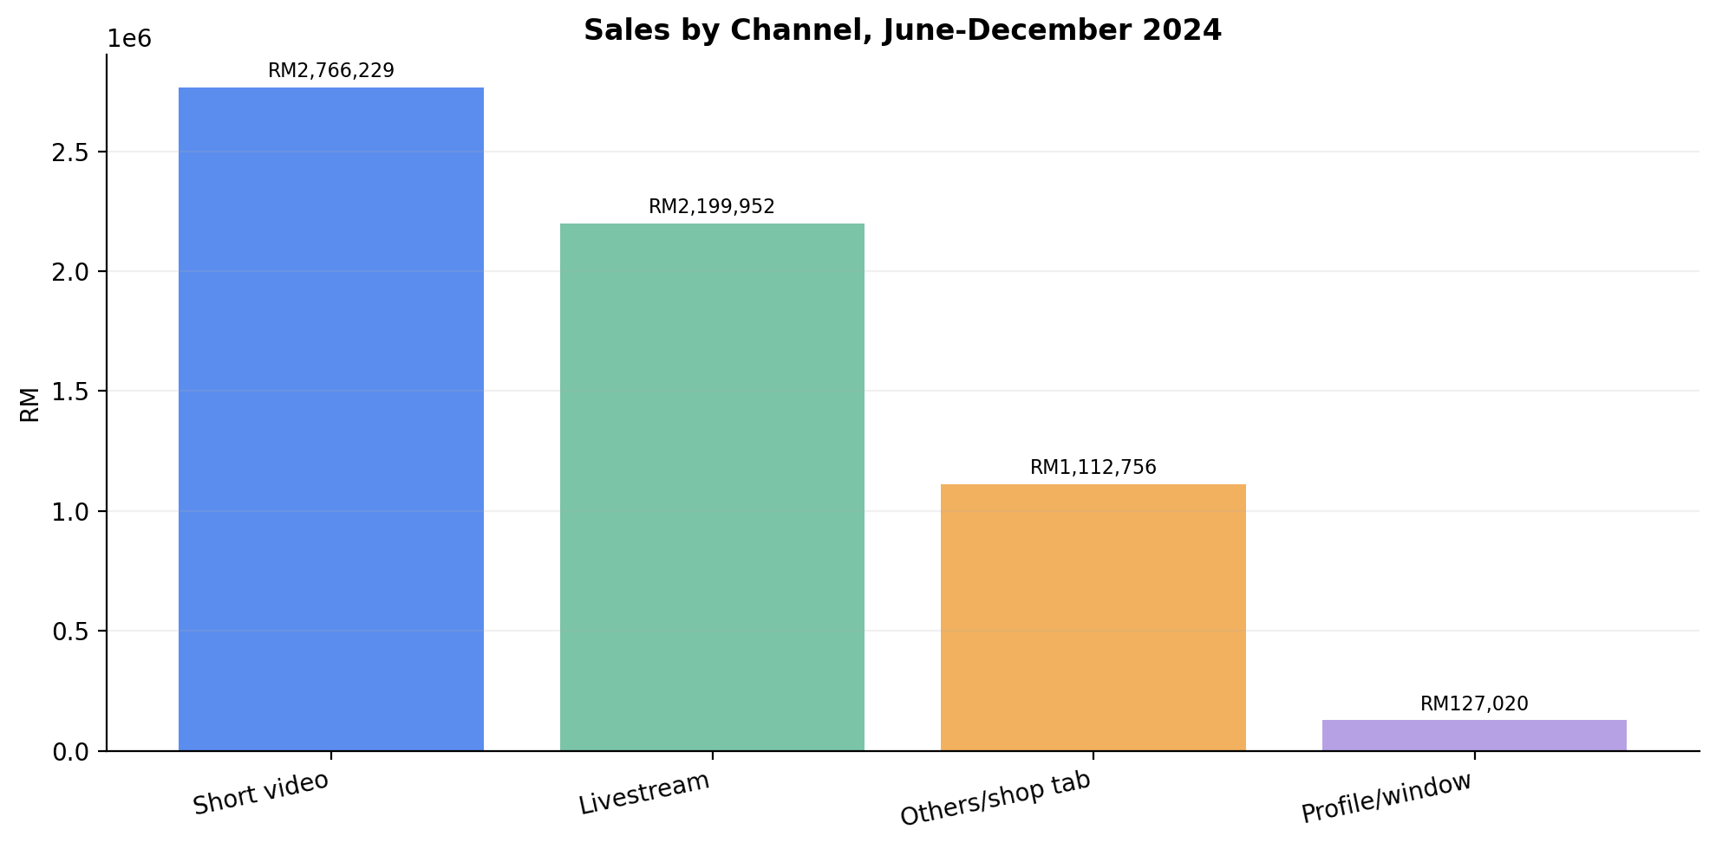
Figure 1. Conceptual framework
The framework positions digital entrepreneurial capability as the core driver of platform monetisation and entrepreneurial performance. Based on the theory section, the following propositions guide interpretation:
H1: Digital entrepreneurial capability is positively associated with platform monetisation.
H2: Platform monetisation is positively associated with entrepreneurial performance.
H3: Opportunity recognition strengthens the relationship between capability and monetisation.
H4: Institutional support enhances the translation of platform execution into sales performance.

5. Methodology

5.1 Research philosophy and design
The study follows a pragmatic quantitative design. The unit of evidence is the programme itself, but the analytical emphasis is entrepreneurial capability rather than programme administration. The design combines descriptive analysis of sales distribution with aggregate correlation analysis of monthly programme indicators.

5.2 Data source and sampling
The data come from the official FAMA performance report for the Agromarketing Masterclass TikTok Shop Edition. The dataset covers 80 companies and 160 entrepreneurs across June to December 2024. It includes sales by channel, monthly sales, order counts, products sold, seller GMV and the geographic distribution of participants.

5.3 Measures
Key measures include cumulative sales, channel sales, monthly sales, orders, products sold, seller GMV and the number of participating companies. In entrepreneurship terms, these are treated as indicators of monetisation, execution and capability conversion.

5.4 Analytical procedures
The study uses descriptive statistics to summarise programme structure and Pearson correlations to assess the association between sales and platform indicators. Because the data are monthly aggregates, results are interpreted as programme-level relationships rather than causal seller-level effects.

5.5 Ethics and reliability
The analysis uses de-identified programme records. No participant-level personal information is analysed. Reliability is strengthened by using official administrative data rather than self-reported survey responses.

6. Results

6.1 Programme scale
The programme involved 80 companies, 160 participants and 425 SKUs. It generated RM6,205,957.06 in cumulative sales and an ROI of approximately 1:31. The state distribution shows the strongest participation in Selangor, followed by Perak and Kelantan.

6.2 Channel monetisation
Table 1 shows that short video and livestream were the most important sales channels.
Channel | Sales (RM) | Share
Short video | 2,766,229.44 | 44.6%
Livestream | 2,199,951.99 | 35.4%
Others / shop tab | 1,112,755.54 | 17.9%
Profile / window | 127,020.07 | 2.0%

6.3 Monthly performance
Figure 2 shows the monthly sales trend, with a clear rise toward November and December.
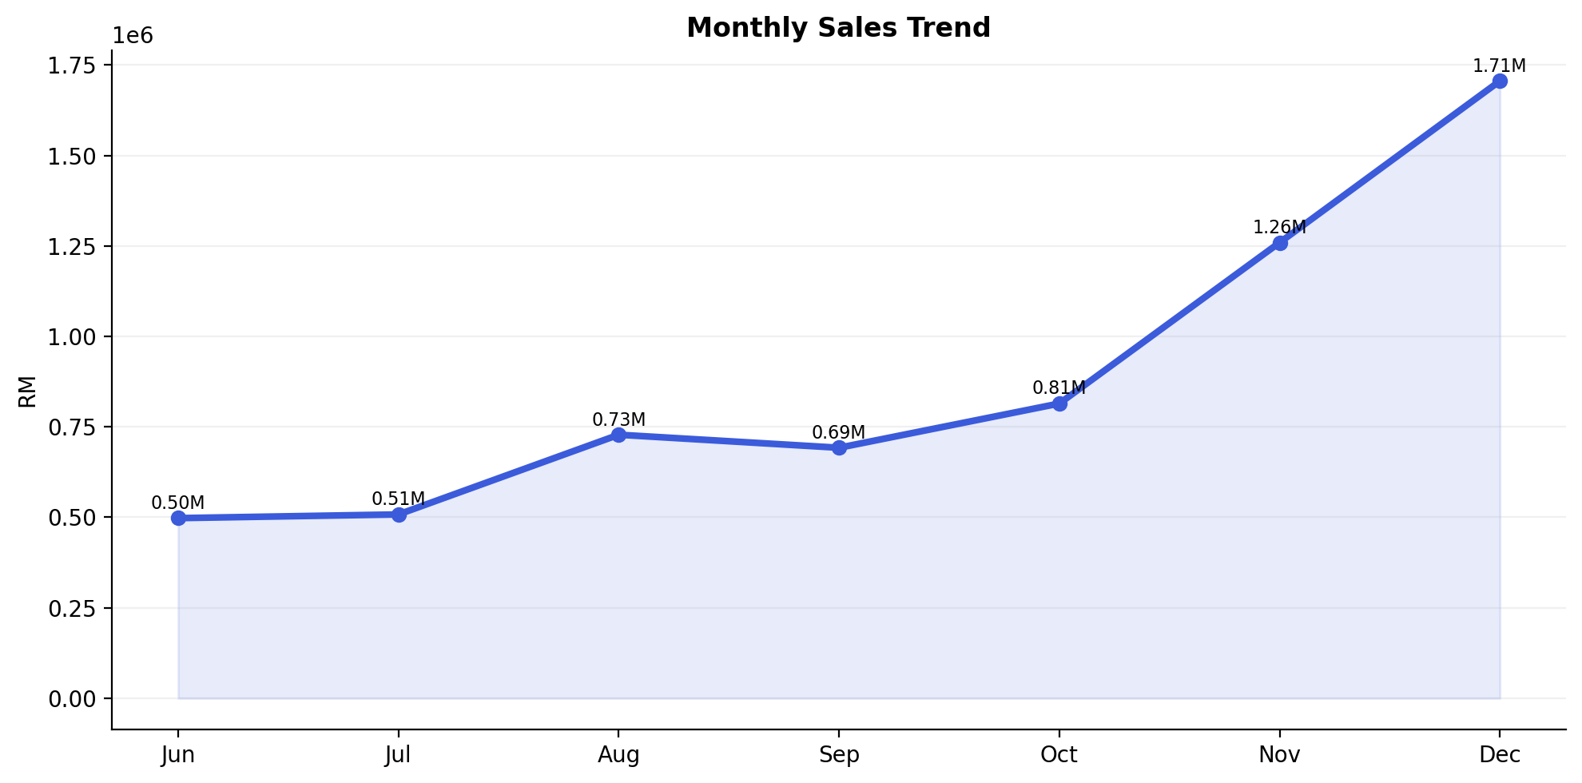
Figure 2. Monthly sales trend
Table 2 summarises monthly growth.
Month | Total Sales (RM) | Orders | Products Sold
June | 497,762.95 | 3,271 | 21,280
July | 507,967.92 | 3,381 | 22,298
August | 728,225.46 | 4,645 | 34,583
September | 692,259.02 | 7,159 | 25,617
October | 814,482.14 | 6,164 | 32,334
November | 1,259,317.52 | 10,194 | 37,804
December | 1,705,942.05 | 14,571 | 45,192

6.4 Concentration effects
Figure 3 shows the top sellers by GMV.
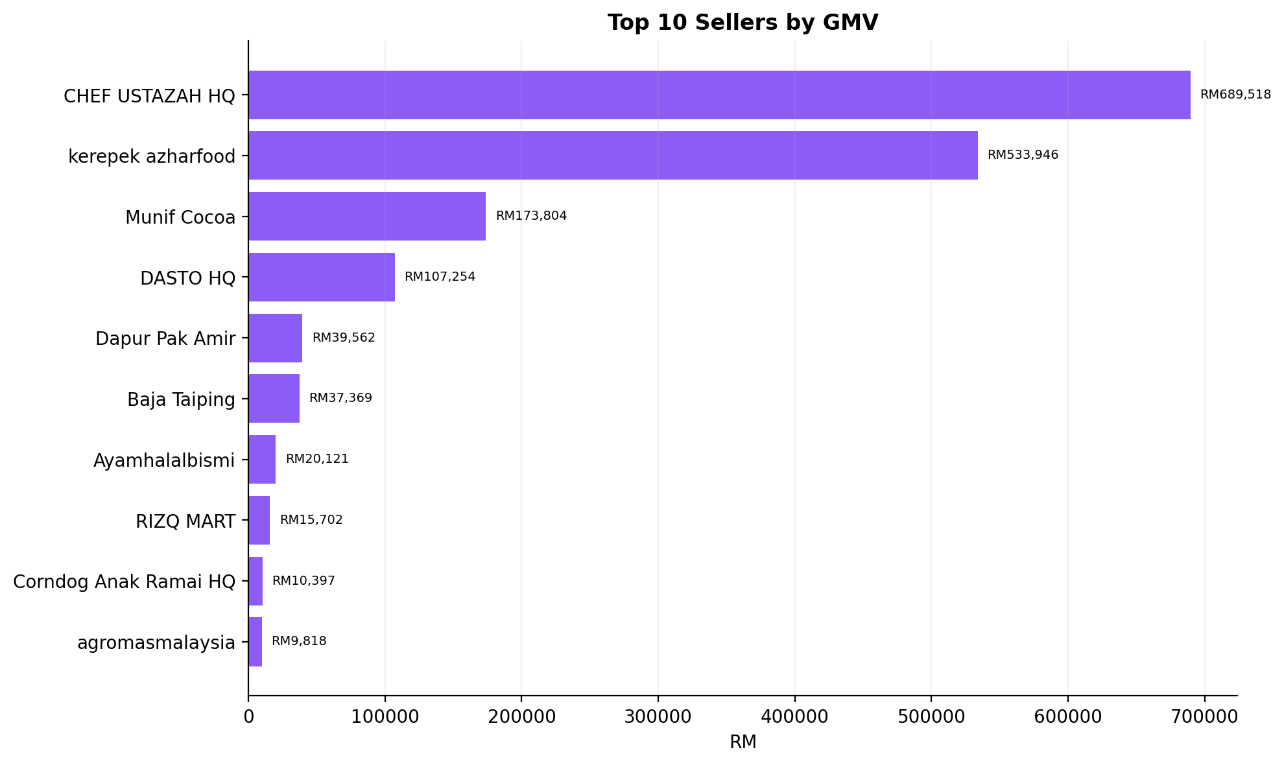
Figure 3. Top sellers by GMV
The top ten sellers are responsible for a disproportionate share of GMV, indicating that capability conversion is uneven across participants.

6.5 Correlation evidence
Figure 4 shows the correlations between total monthly sales and the main programme indicators.
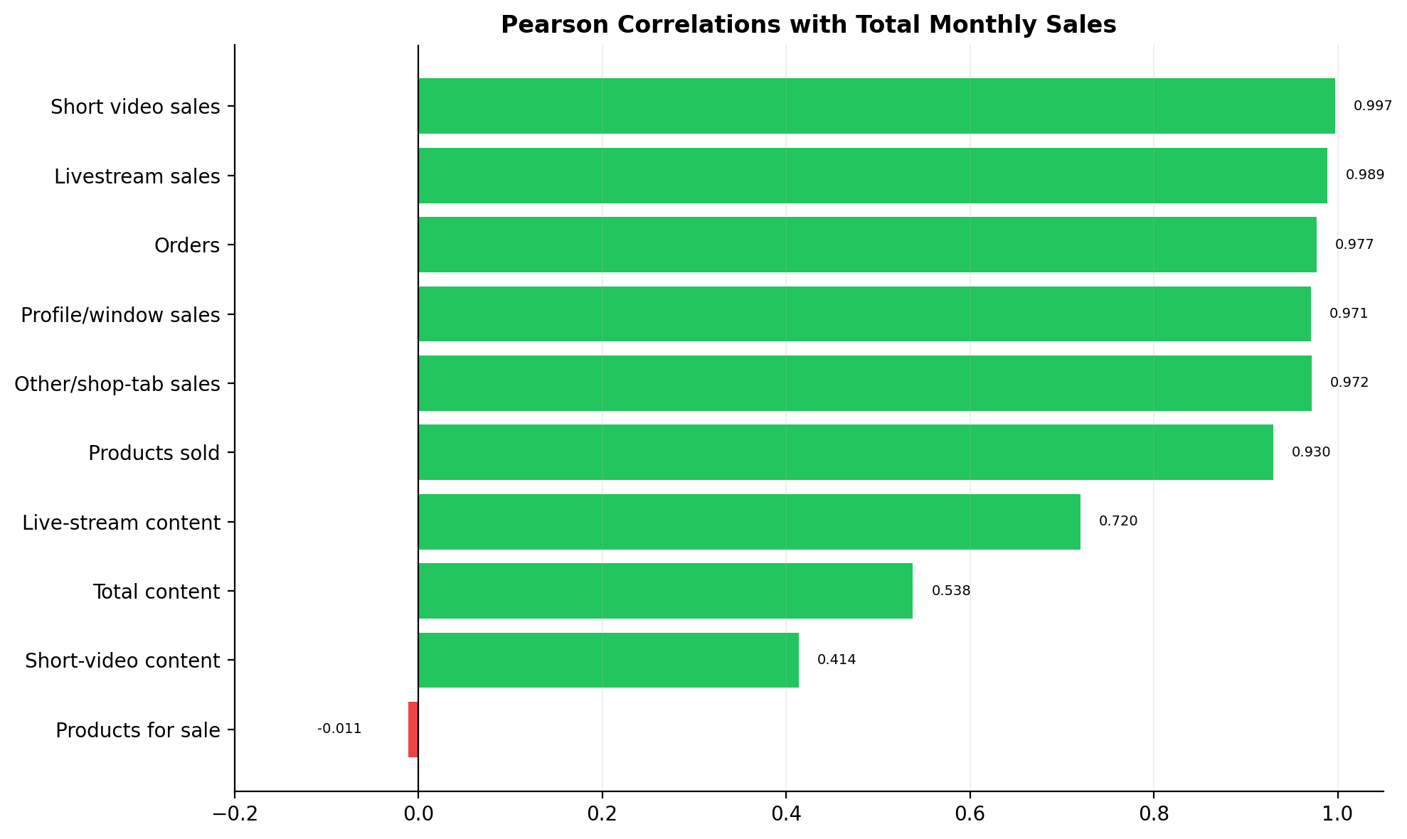
Figure 4. Correlation analysis
The strongest positive correlations are with short-video sales, livestream sales, orders and products sold. Content volume is not consistently significant, which suggests that entrepreneurial quality matters more than posting quantity.

6.6 Geographic spread
Figure 5 shows participation by state.
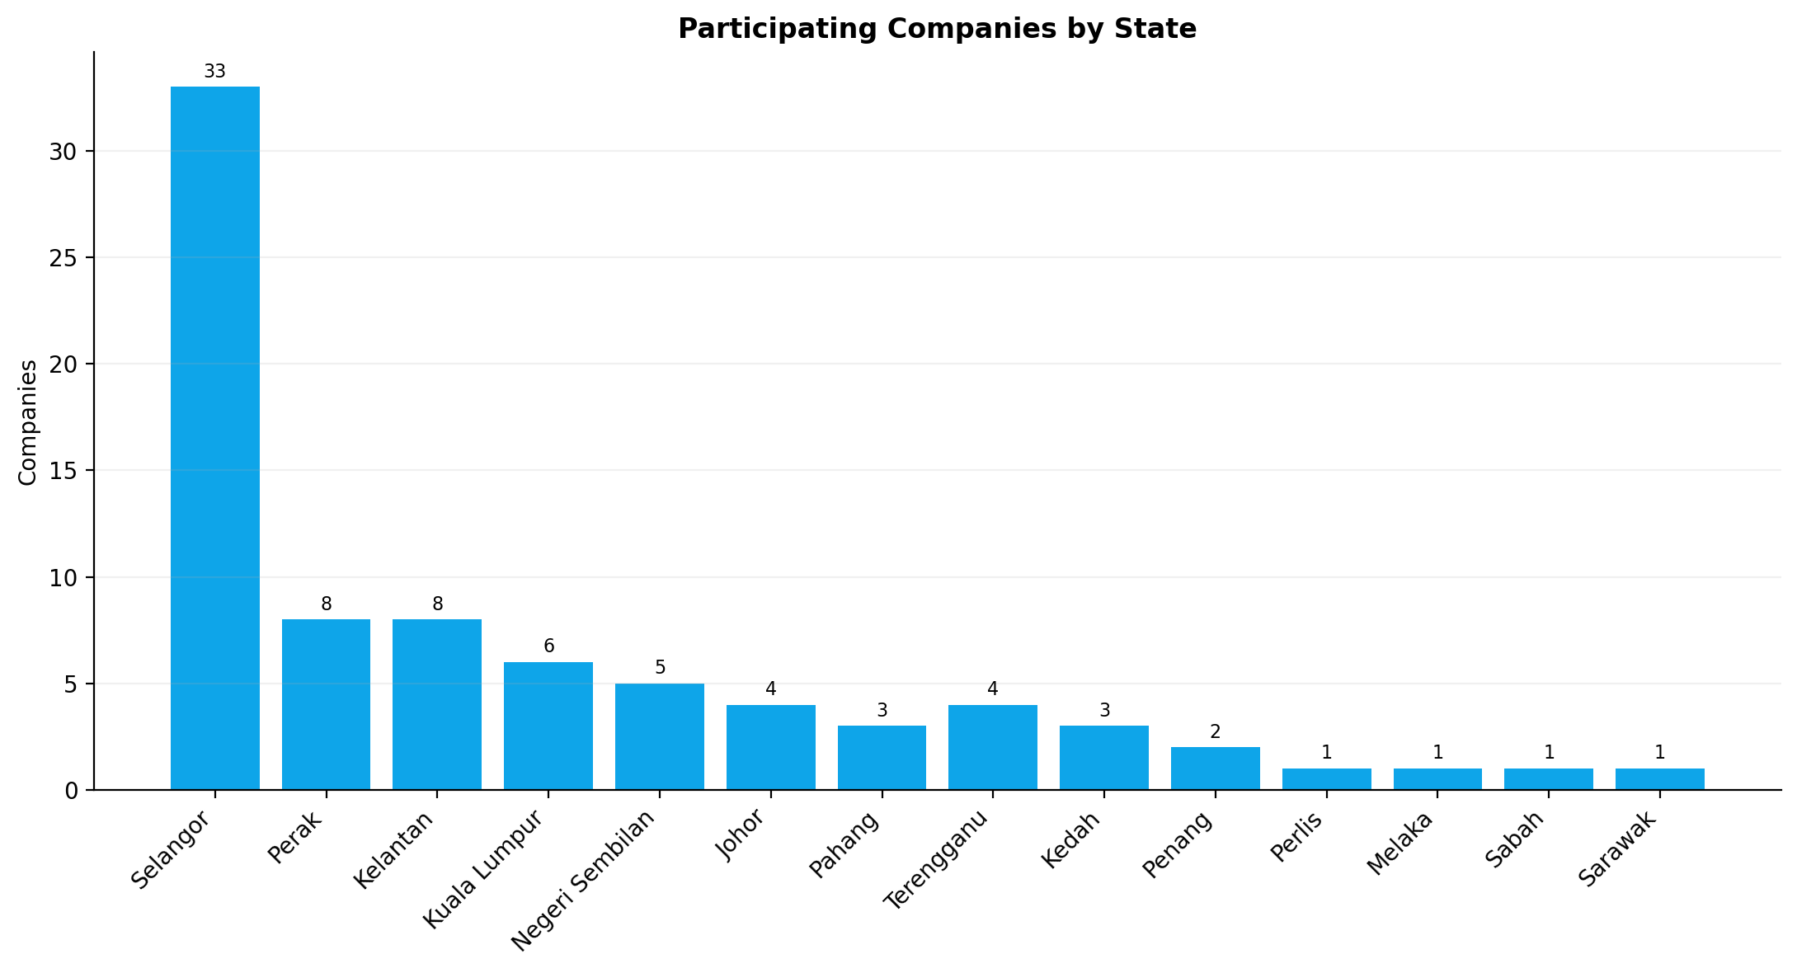
Figure 5. State distribution
Selangor dominates participation, indicating that digital ecosystem maturity influences programme uptake.

7. Discussion
The findings support a stronger entrepreneurship interpretation of the programme. First, the evidence shows that digital entrepreneurial capability is not abstract. It is visible in how entrepreneurs use short video, livestreaming and product presentation to generate sales. Second, the results suggest that opportunity recognition occurs through repeated platform practice rather than through one-off training. Third, the concentration of GMV among a small number of sellers shows that capability development is uneven and requires differentiated support.
From a platform entrepreneurship perspective, the programme demonstrates that social commerce success depends on execution quality. Posting more content does not automatically produce more sales. Instead, the entrepreneur must shape the content into a sales process. That aligns with recent digital entrepreneurship literature, which treats platform adaptation as a continuous learning process.
The findings also matter for ASEAN entrepreneurship policy. Public agencies should not measure success only by participation or enrolment. They should monitor monetisation, conversion and seller progression. The FAMA case suggests that public-sector interventions can be economically meaningful when they are designed around marketplace behaviour rather than classroom attendance.

8. Contributions

8.1 Theoretical contributions
The study extends resource-based theory by showing that social commerce execution can be treated as a strategic entrepreneurial resource. It extends dynamic capability theory by showing that capability renewal happens through platform feedback loops. It also contributes to platform entrepreneurship by showing how public-sector interventions can shape monetisation routines.

8.2 Practical contributions
For entrepreneurs, the study highlights the importance of content-to-order conversion. For SMEs, it shows that short-video and livestream routines are commercially powerful. For FAMA and similar agencies, it suggests that training should include conversion scripts, fulfilment discipline and analytics review. For educators, the case can be used to teach opportunity recognition and digital execution.

8.3 Policy contributions
Policy makers should move from participation metrics to monetisation metrics. Support should be tiered by seller capability, with coaching for low performers and scale-up support for high performers. ASEAN entrepreneurship initiatives can adopt similar models for digital market access.

9. Conclusion
The Agromarketing Masterclass TikTok Shop Edition demonstrates that platform monetisation can function as a measurable entrepreneurship capability outcome. The programme generated strong sales, substantial ROI and clear evidence that monetised channels matter more than content volume alone. The study’s main contribution is conceptual: it reframes public-sector social commerce as digital entrepreneurial capability development rather than programme evaluation.
Limitations remain. The dataset is monthly aggregate evidence, so seller-level causality cannot be claimed. Future research should collect seller-level views, live duration, click-through rates, repeat purchases and customer retention. Even so, the case offers a robust entrepreneurship story for ASEAN: when training, platform access and monitoring are integrated, social commerce can become a credible route to SME growth.

Author Contributions
Abd Razzif Abd Razak: conceptualisation, resources, data curation, writing - original draft, visualisation, supervision, project administration.
Siti Faizah Zainal: conceptualisation, validation, data curation, visualisation, project administration.
Siti Nurulaini Azmi: methodology, validation, resources, writing - original draft, supervision.
Nur Hafizah Roslan: methodology, software, formal analysis, investigation, writing - review and editing.
Nur Syairah Ani: software, formal analysis, investigation, writing - review and editing.

Funding
This research received no external funding.

Acknowledgements
The authors express sincere appreciation to the Federal Agricultural Marketing Authority (FAMA), TikTok Shop Malaysia and all participating entrepreneurs involved in the Agromarketing Masterclass TikTok Shop Edition. Appreciation is also extended to the programme implementation and monitoring teams who contributed to the availability of performance data used in this study.

Conflict of Interest
The authors declare no conflict of interest.

References
Barney, J. (1991). Firm resources and sustained competitive advantage. Journal of Management, 17(1), 99-120. https://doi.org/10.1177/014920639101700108
Creswell, J. W., & Creswell, J. D. (2018). Research design: Qualitative, quantitative, and mixed methods approaches (5th ed.). SAGE.
FAMA. (2024). Projek Perintis Report (December 2024): Agromarketing Masterclass TikTok Shop Edition performance dataset. Federal Agricultural Marketing Authority.
Hajli, N. (2015). Social commerce constructs and consumer’s intention to buy. International Journal of Information Management, 35(2), 183-191. https://doi.org/10.1016/j.ijinfomgt.2014.12.005
Halim, I. A., Gian Singh, J. K., & Osman, R. (2026). Bridging the digital gap: Factors influencing digital economy adoption in small enterprises. Journal of International Business, Economics and Entrepreneurship, 11(1), 32-42. https://doi.org/10.24191/jibe.v11i1.8520
Kraus, S., Palmer, C., Kailer, N., Kallinger, F. L., & Spitzer, J. (2022). Digital entrepreneurship: A research agenda on new business models for the twenty-first century. International Journal of Entrepreneurial Behavior & Research, 28(5), 1172-1193.
Nambisan, S. (2017). Digital entrepreneurship: Toward a digital technology perspective of entrepreneurship. Entrepreneurship Theory and Practice, 41(6), 1029-1055. https://doi.org/10.1111/etap.12254
Putit, L., Hamzah, M. I., Abdullah, M. F., Syed Annuar, S. N., & Yulianto, A. (2025). Drivers of social media marketing continuance among MSMEs in emerging economies. Journal of International Business, Economics and Entrepreneurship, 10(2), 86-97. https://doi.org/10.24191/jibe.v10i2.8743
Rahim, N. A., Yusuf, M. A., & Che Mat, N. (2024). Social commerce and shoppertainment adoption among Malaysian consumers. Journal of Digital Business and Marketing, 4(2), 45-61.
Raub, N. A. A., Aluwi, A. H., Zainal Abidin, N. I., & Maulida, E. (2025). Strategic marketing and digital transformation for SME empowerment: Insights from a Malaysia-Indonesia service-learning collaboration. Journal of International Business, Economics and Entrepreneurship, 10(2). https://doi.org/10.24191/jibe.v10i2.8197
Rauch, A., & Frese, M. (2007). Let’s put the person back into entrepreneurship research: A meta-analysis on the relationship between business owners’ personality traits, business creation and success. European Journal of Work and Organizational Psychology, 16(4), 353-385. https://doi.org/10.1080/13594320701595438
Shane, S., & Venkataraman, S. (2000). The promise of entrepreneurship as a field of research. Academy of Management Review, 25(1), 217-226. https://doi.org/10.5465/amr.2000.2791611
Teece, D. J. (2018). Business models and dynamic capabilities. Long Range Planning, 51(1), 40-49. https://doi.org/10.1016/j.lrp.2017.06.007
Teece, D. J., Pisano, G., & Shuen, A. (1997). Dynamic capabilities and strategic management. Strategic Management Journal, 18(7), 509-533. https://doi.org/10.1002/(SICI)1097-0266(199708)18:7<509::AID-SMJ882>3.0.CO;2-Z
Yin, R. K. (2018). Case study research and applications: Design and methods (6th ed.). SAGE.

